11/29/2023

Brenda Beach & Jonathan Hardwick

Video Game Library & Sales

Video Game Library & Sales

User Manual

Contents

**Installation of Required Programs to Write Code** 1

**Installation of Python** 1

**Installation of Visual Studio Code** 7

**Clone GitHub Repository CSC289** 14

**Open the Project in Visual Studio Code and Activate the Virtual Environment** 21

**Install All Necessary Modules inside the Virtual Environment** 28

**Initialize the Website** 33

**Using the Website** 35

**Website Registration** 35

# **Installation of Required Programs to Write Code**

Currently, the Video Game Library and Sales program is not set to be run by an executable, so you will need to download and install a couple of programs if you do not already have them. Those programs are Python and Visual Studio Code. You can use a different IDE other than Visual Studio Code, but for this installation manual, we will be using Visual Studio Code.

## **Installation of Python**

1. The first thing you need to do to install Python onto your system is to go to the website <https://www.python.org>.

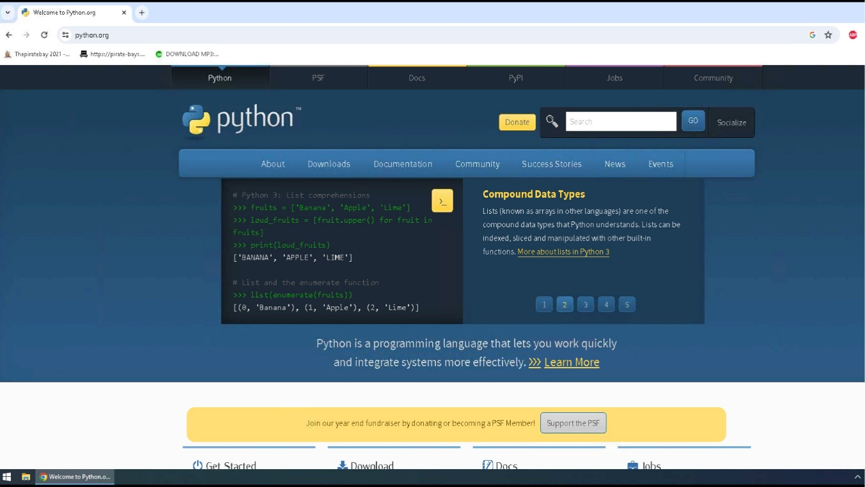

1. Once you have arrived at the website, you will click on the Downloads link and then click on the link to download the latest version of Python onto your system.

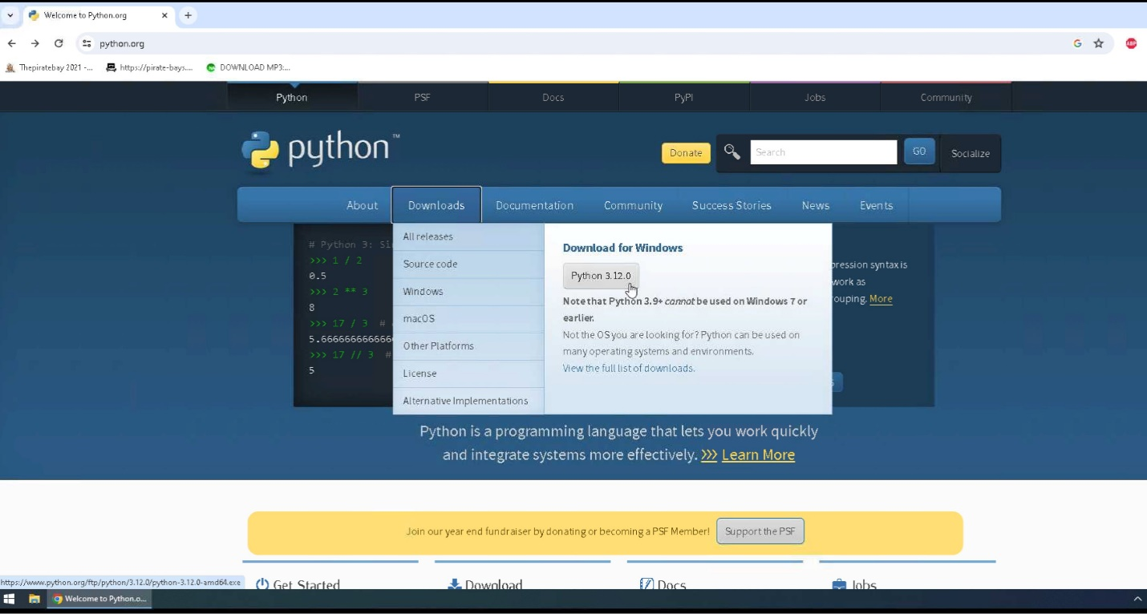

1. Python will download to your default downloads folder, and once it has been completed, you can click on the icon to view your downloaded file names in the upper right corner of your webpage so you can click on that file name and install the program onto your system.

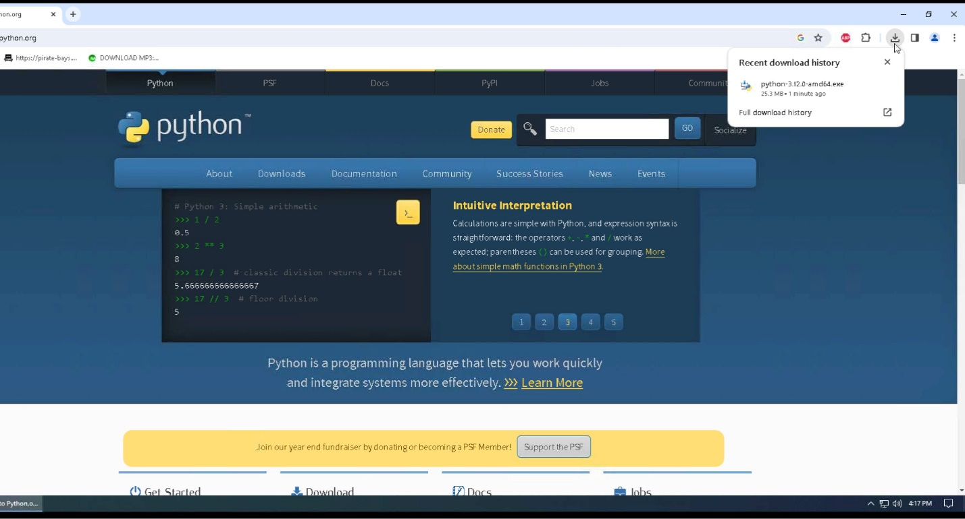

1. Click on run to install Python onto your system.

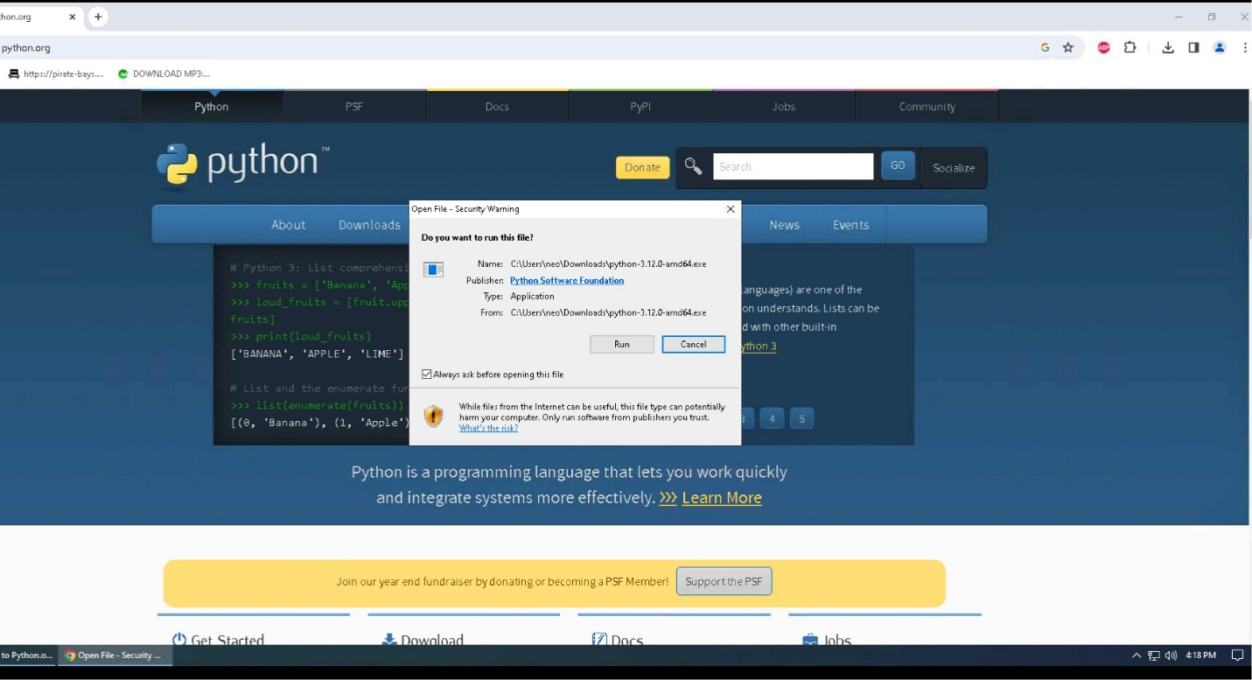

1. Click “Add Python to PATH,” then click Install Now.

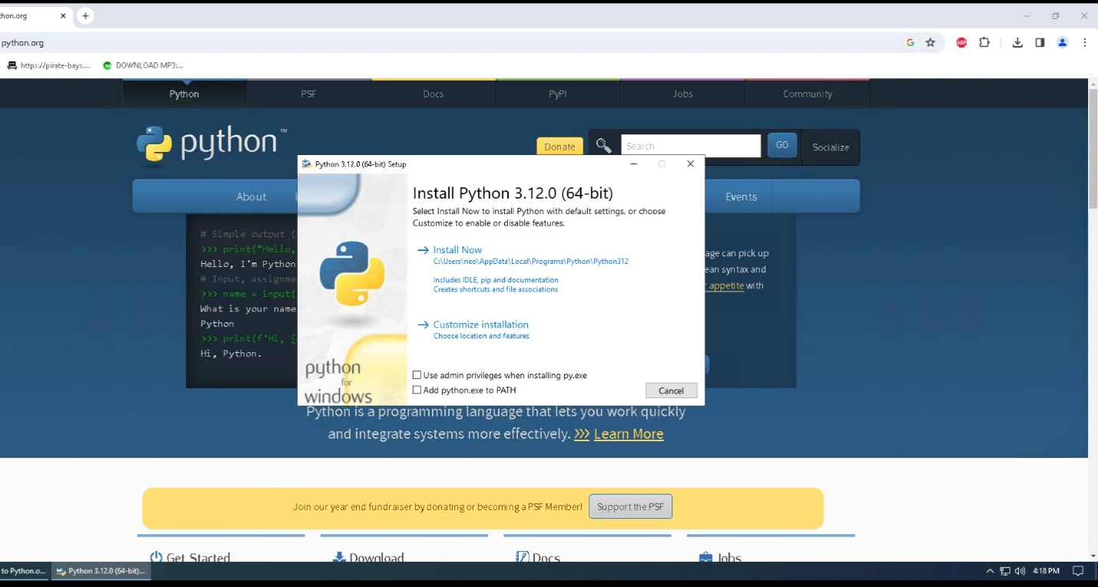

1. The program will now be installed on your system, and the status bar will show the progress level of the installation.

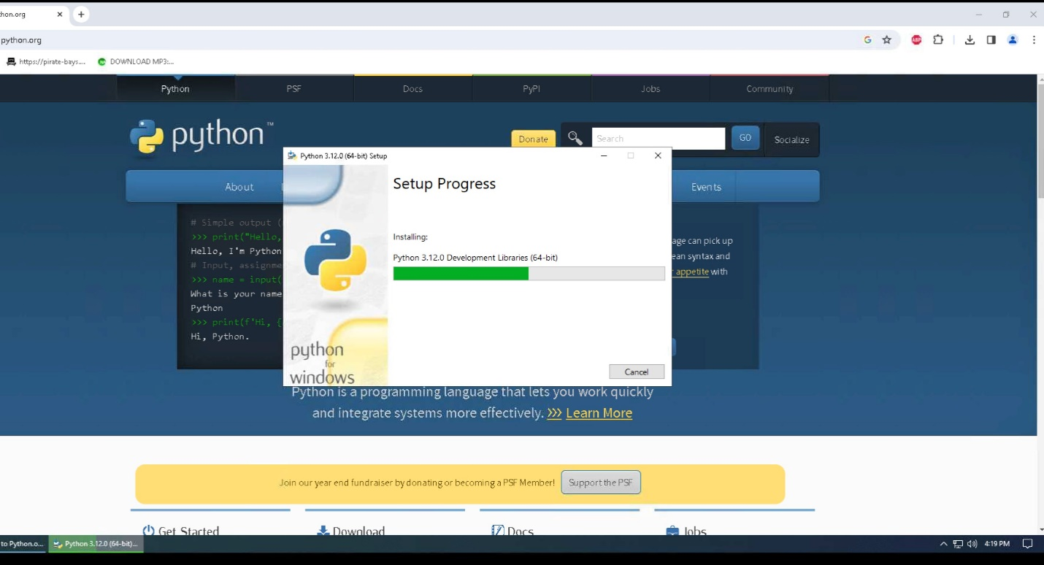

1. Once the installation is finished, click on Close to close the setup window. You can then close the web browser.

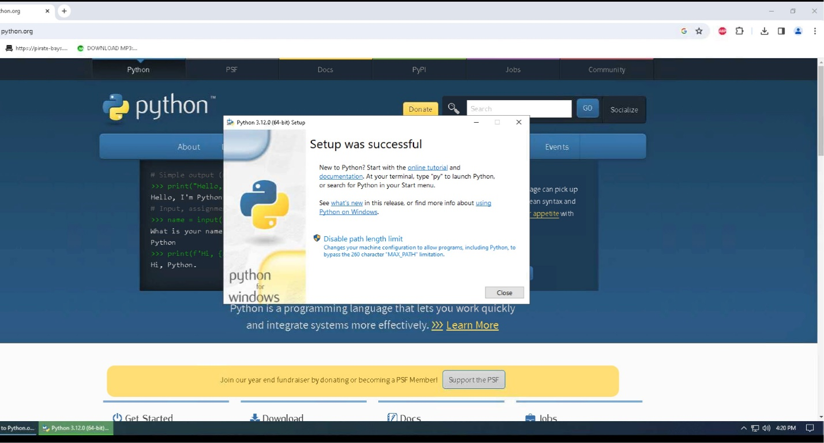

1. To verify the installation of Python onto your system, you can click on the Windows icon, also known as your start button, and under the recently added programs, you should see the Python program.

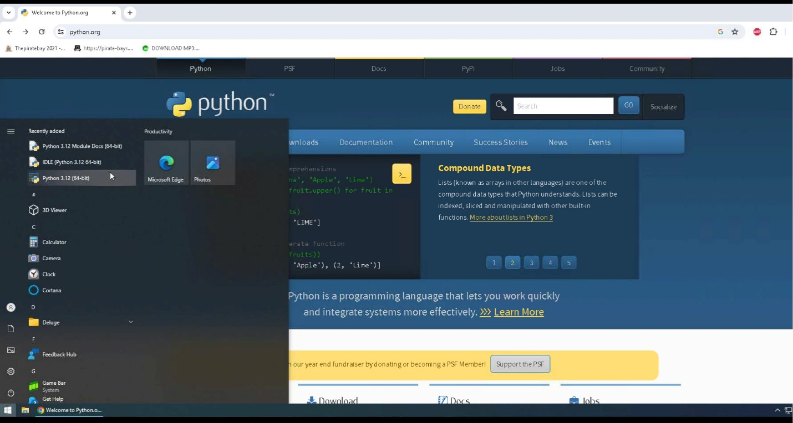

1. You can also verify that Python installed on your system by opening a command prompt, and typing python –version. If you get an error message when you run this command, you must repeat these steps to reinstall Python on your system.

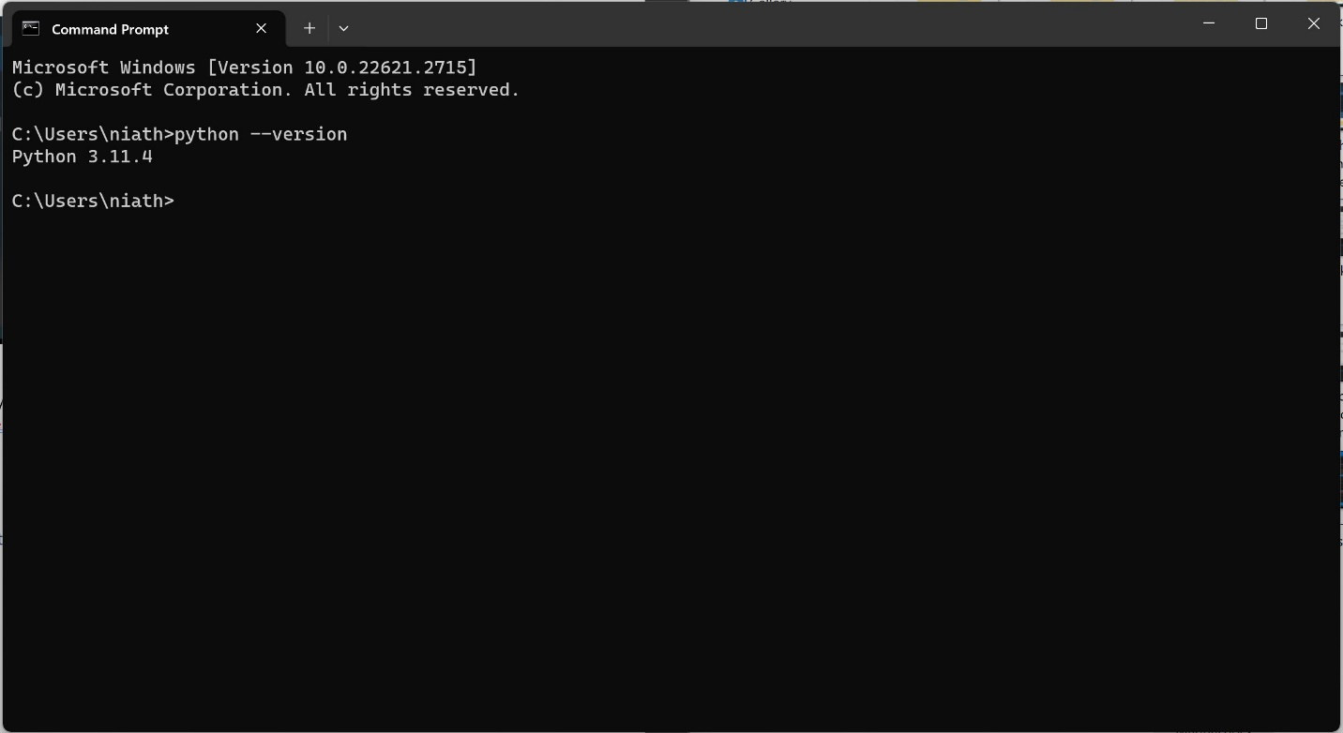

1. Now that Python is installed on your system, it is time to install our IDE so we can view our code and run the program.

## **Installation of Visual Studio Code**

1. To install Visual Studio Code, go to the webpage <https://code.visualstudio.com>.

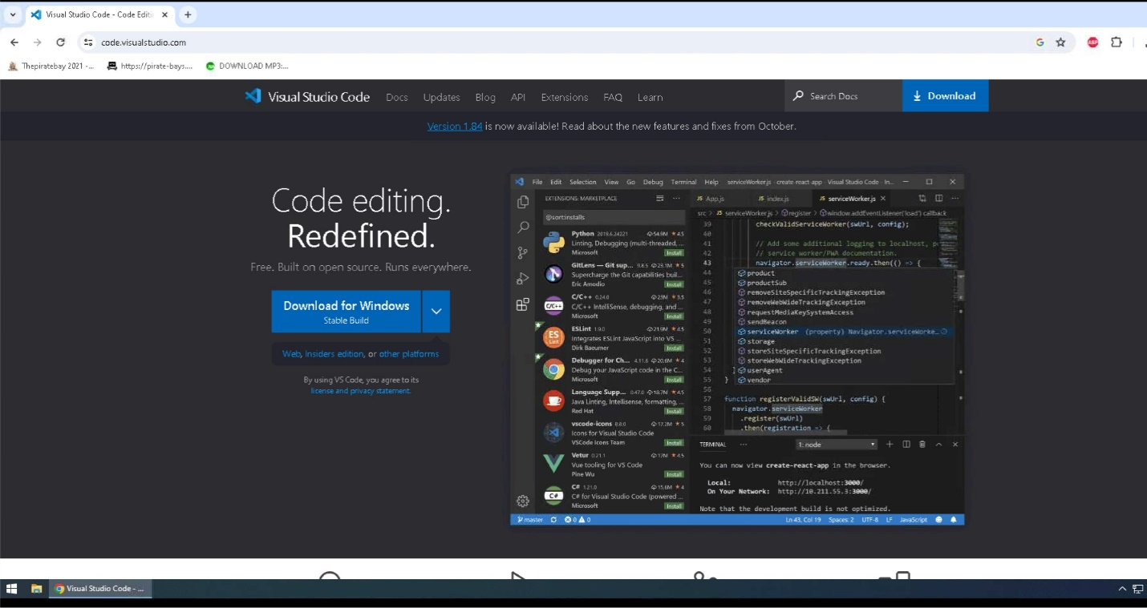

1. Click on download to download to your default downloads folder, and once it has been completed, you can click on the icon to view your downloaded file names in the upper right corner of your webpage.

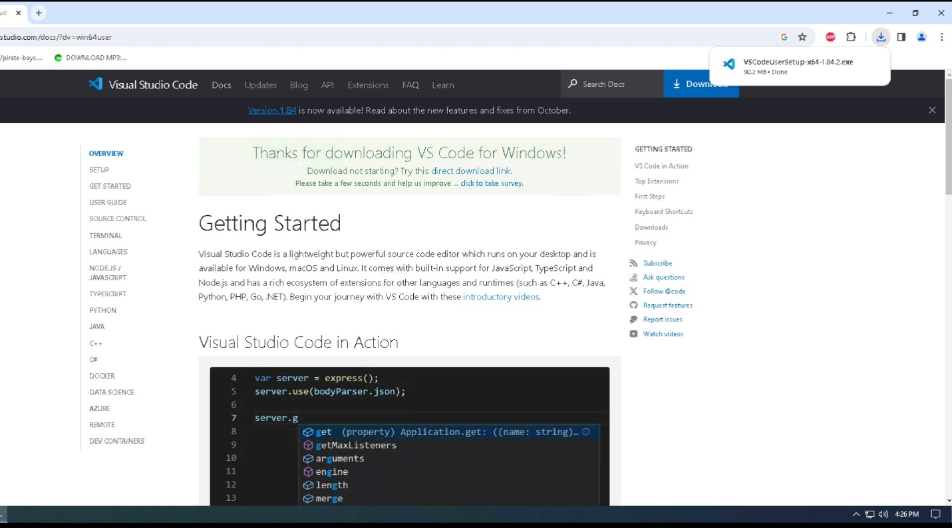

1. Click on the file name to install Visual Studio Code on your system.

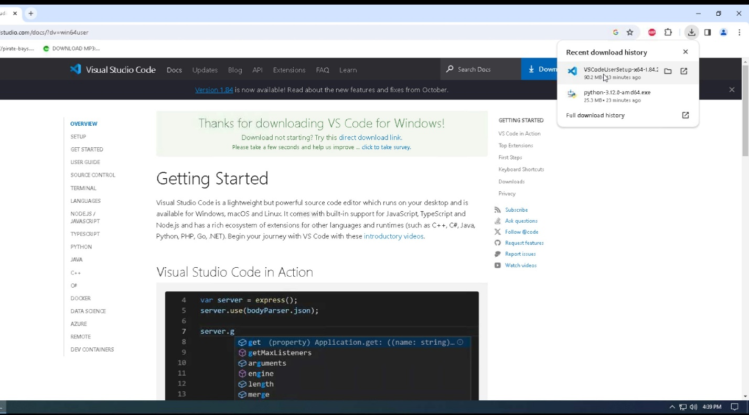

1. Click on run to begin the installation of Visual Studio Code.

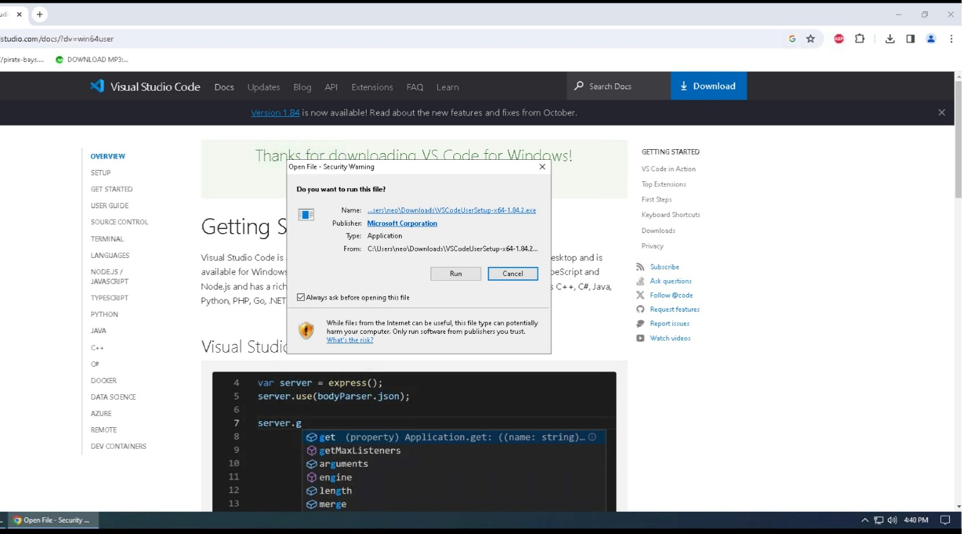

1. Click on I accept the agreement, then click on Next.

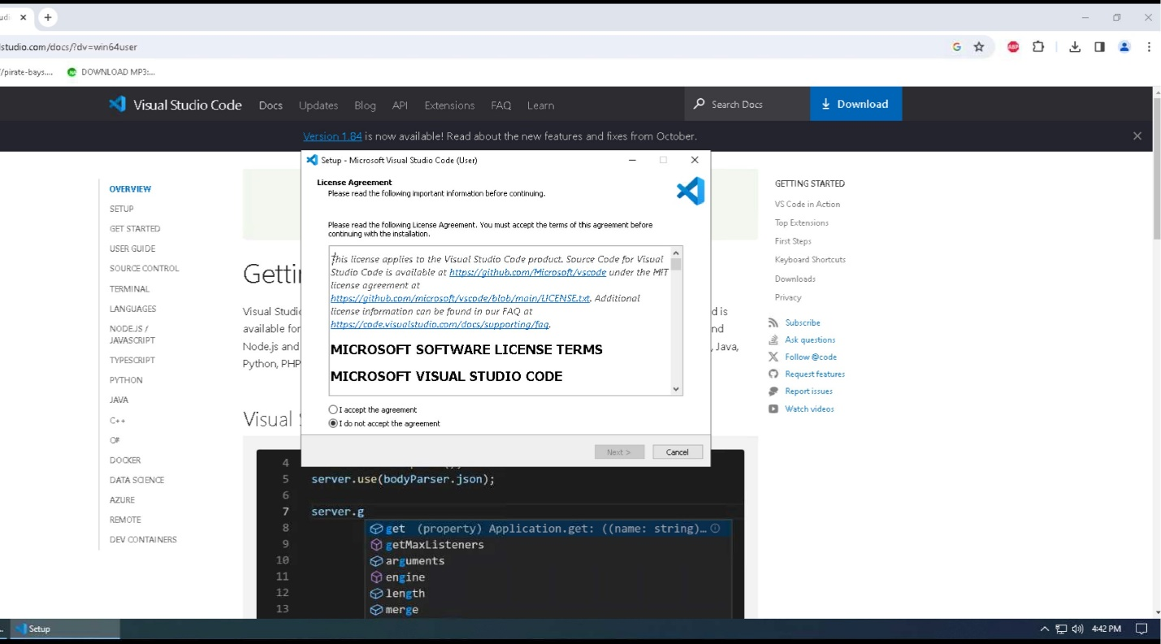

1. Click Browse to select the location to install the program or leave it as the default location. Click Next to continue.

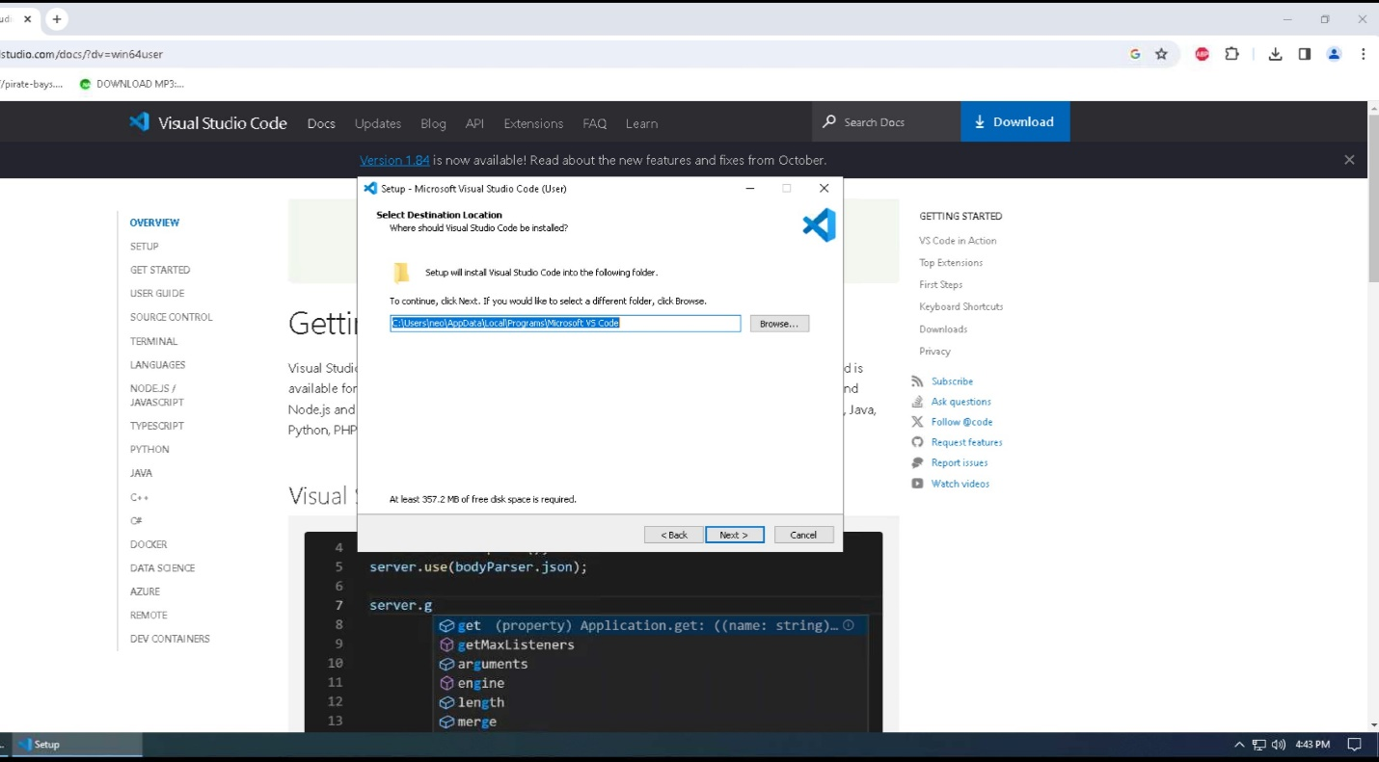

1. Click Next to accept the default location and continue to the next step in the installation process.

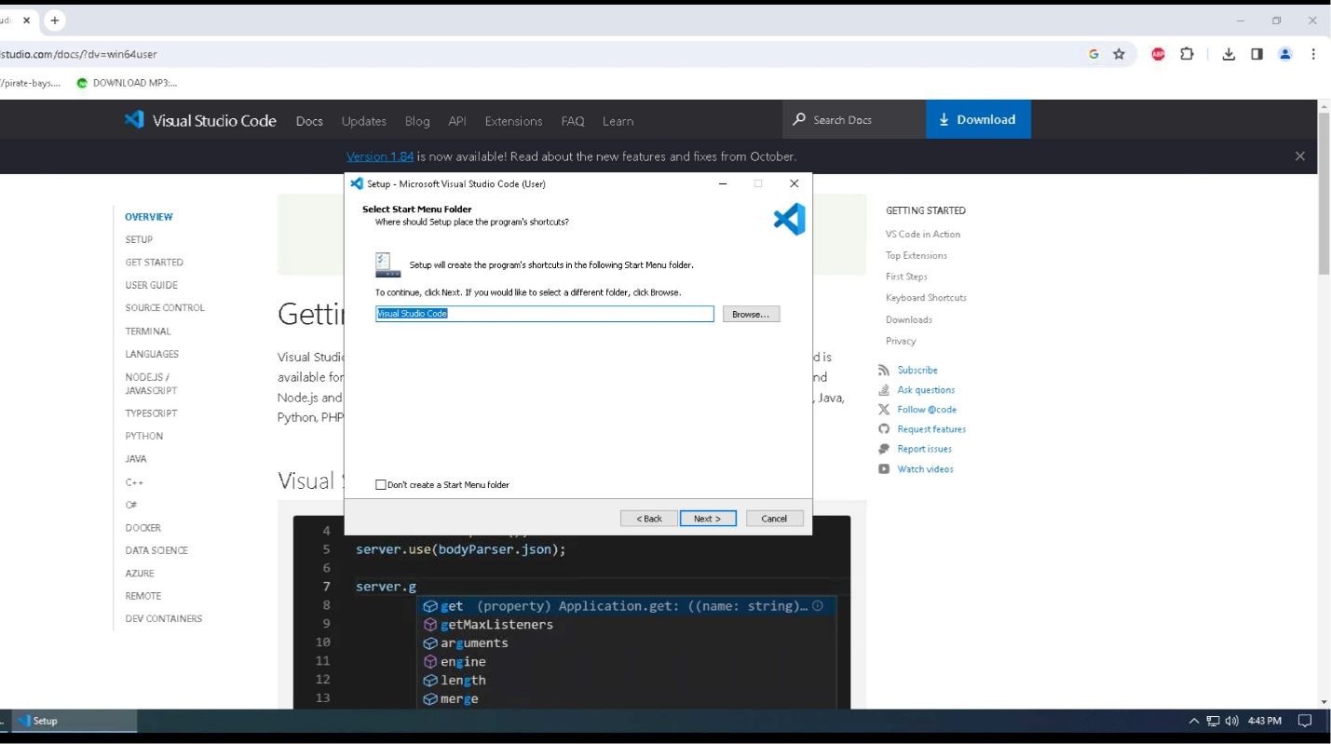

1. Click Create Desktop Icon, then click Next to continue to the next step of the installation process.

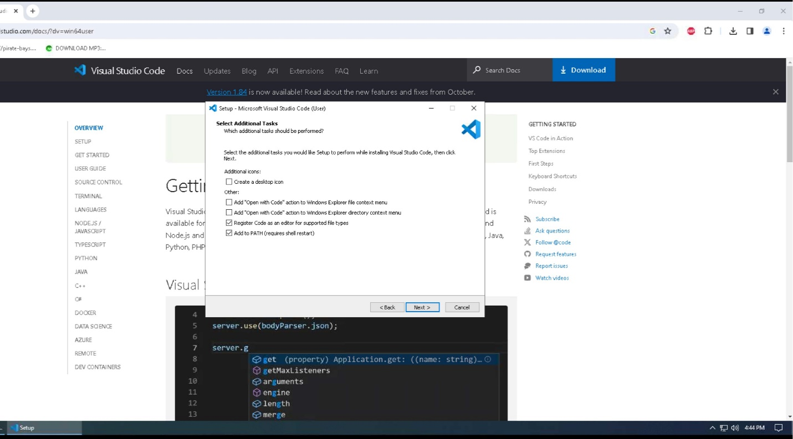

1. Click Install to install Visual Studio Code onto your system.

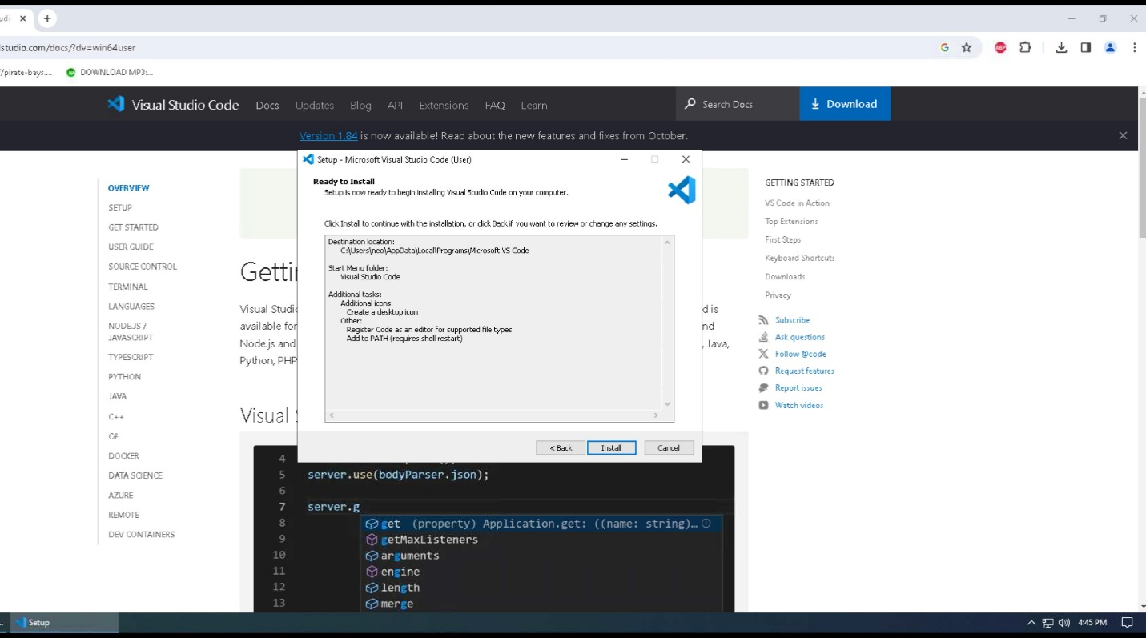

1. Visual Studio Code will now be installed on your system, and the status bar will show you the progress of that installation.

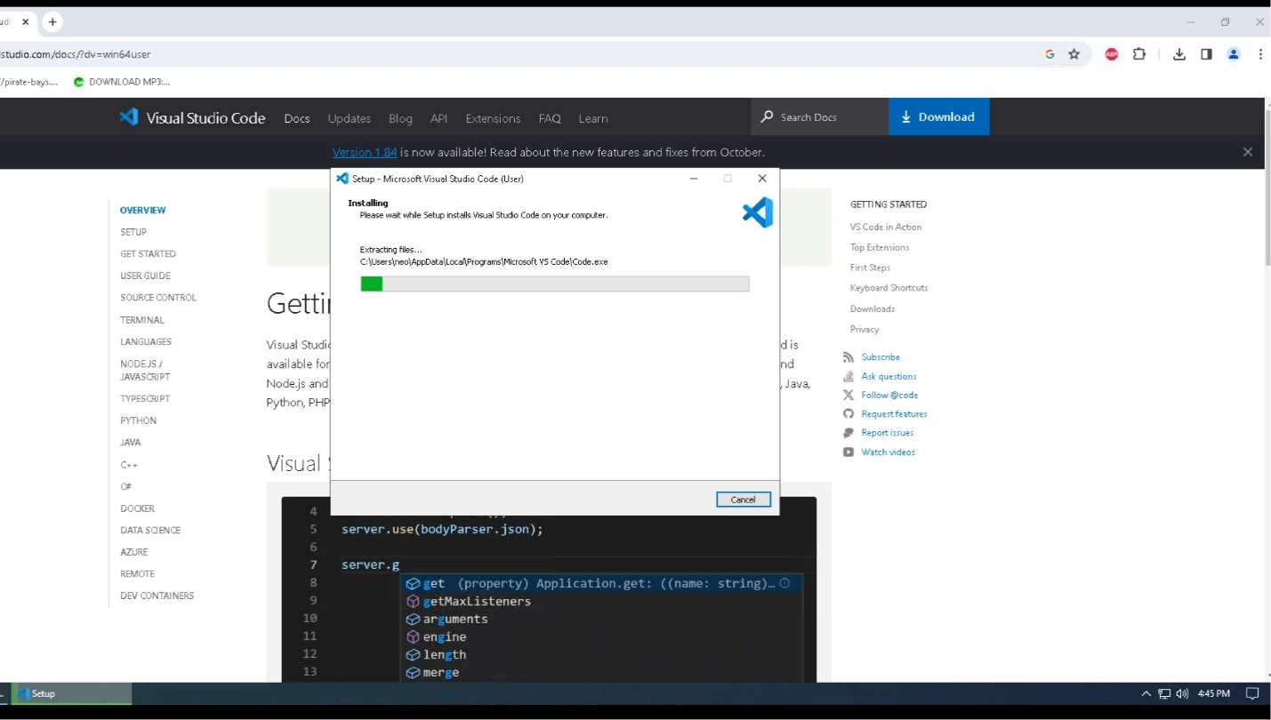

1. Once the program has been installed, ensure that the “Launch Visual Studio Code” is checked before you click Finish. This will close out the installation window and start the Visual Studio Code. You can also go ahead and close the web browser.

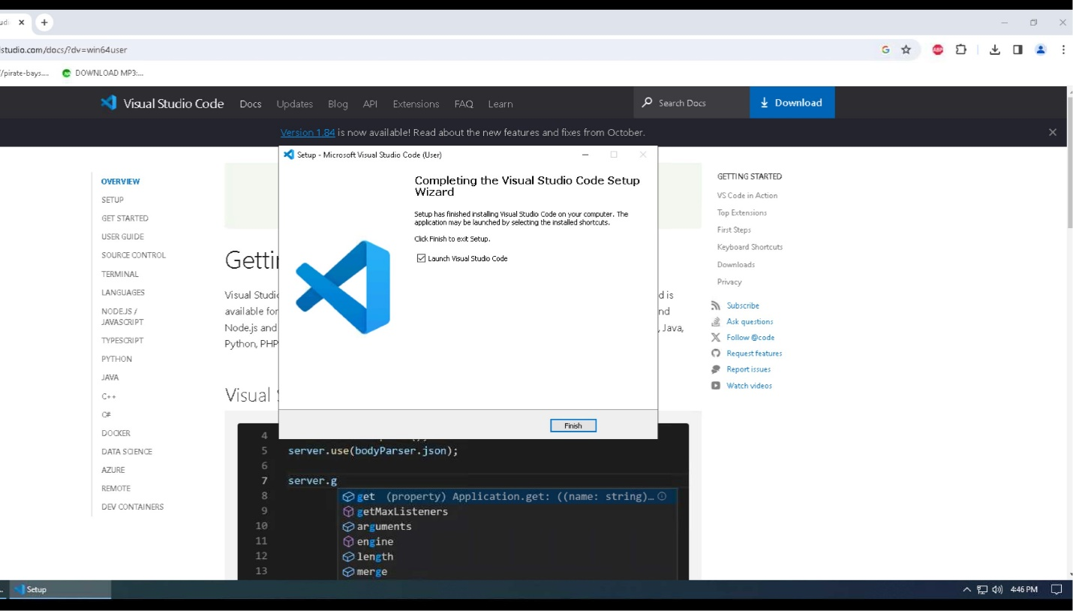

1. Visual Studio Code will now open. You will need to click on the extensions icon so we can install the Python extension and write our Python code inside Visual Studio Code.

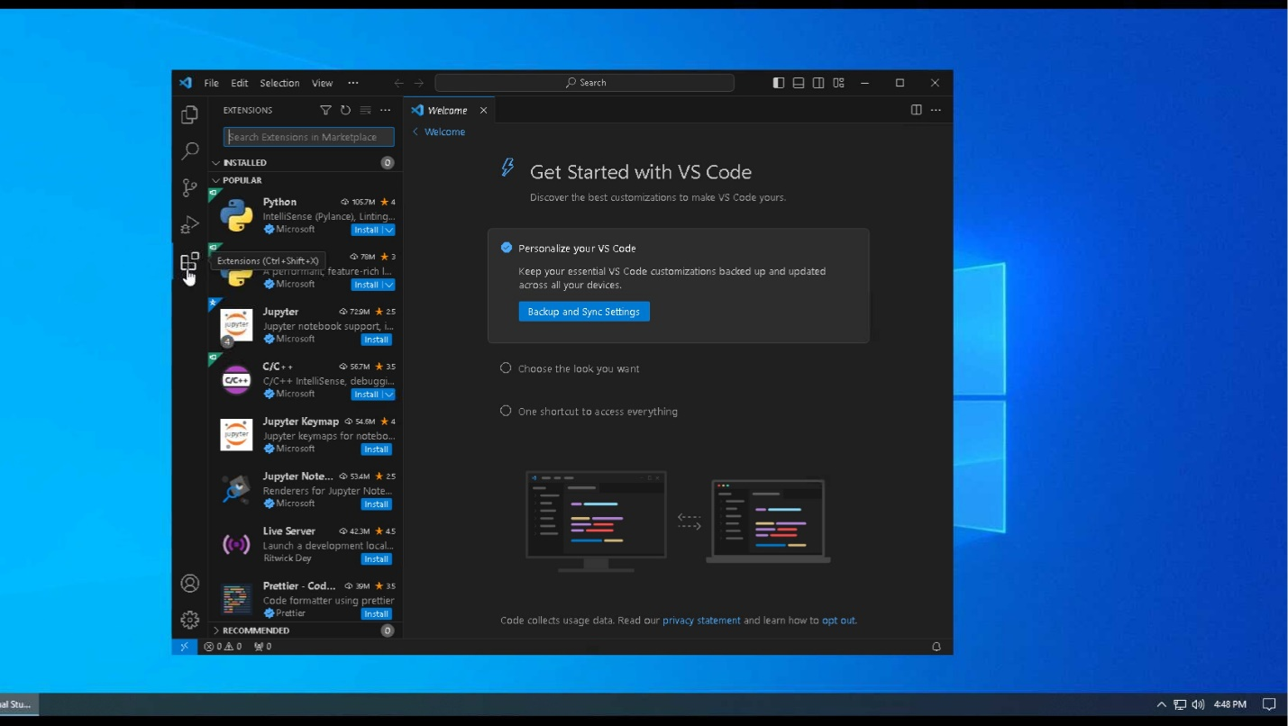

1. Click on Install under the Python Extension.

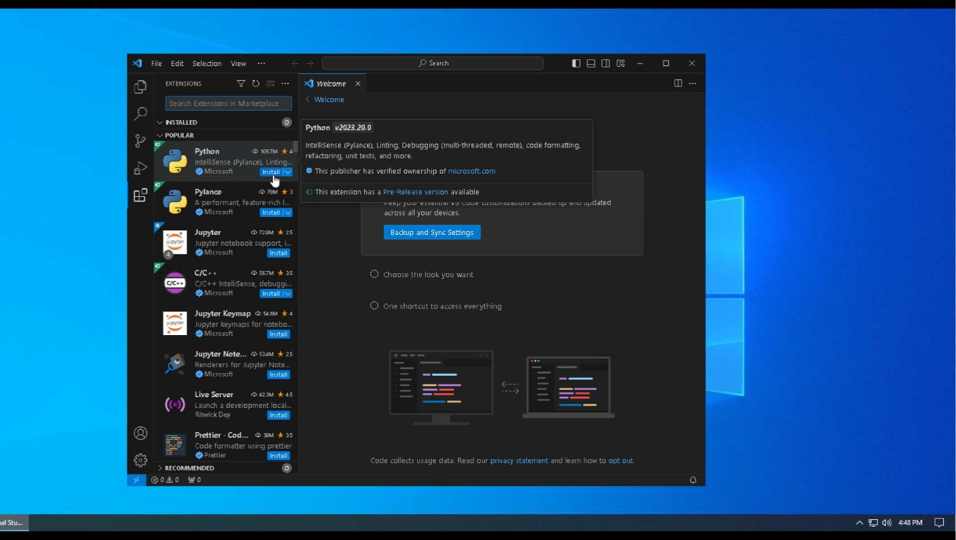

1. It will then install the Python extension. Once it is finished, you can write your Python code without receiving any errors.

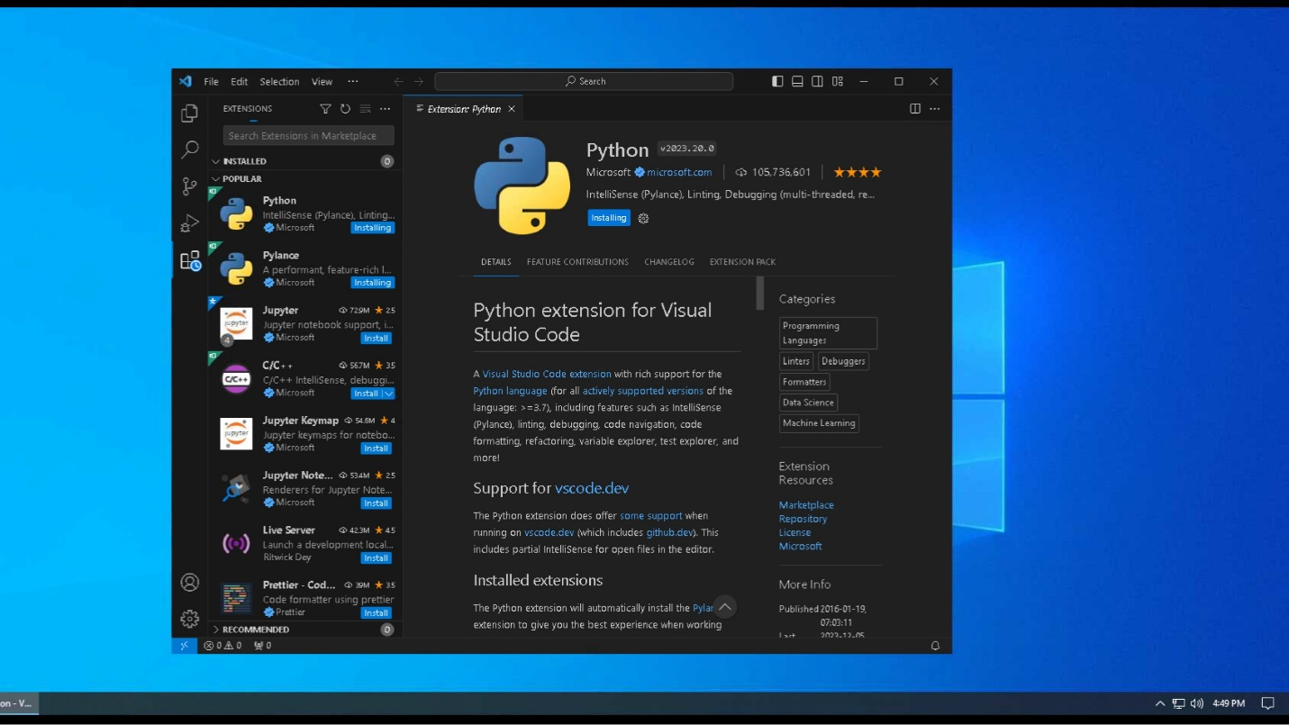

# **Clone GitHub Repository CSC289**

1. Go to the URL of <https://github.com/MrChiff/CSC289>.

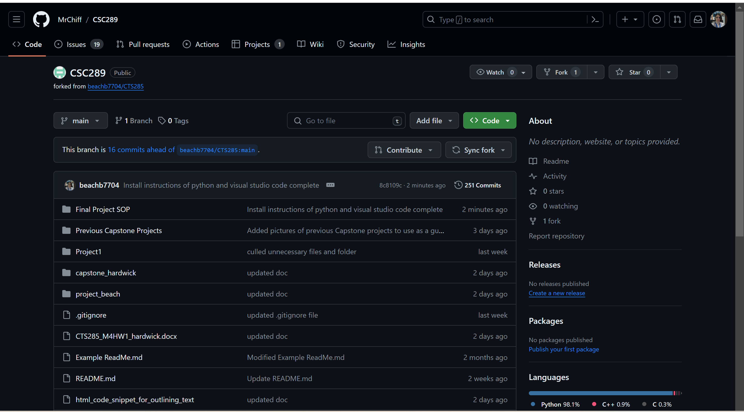

1. To download the code in a zipped file, click on the green button that says “<>Code” and then click on the Local Tab.

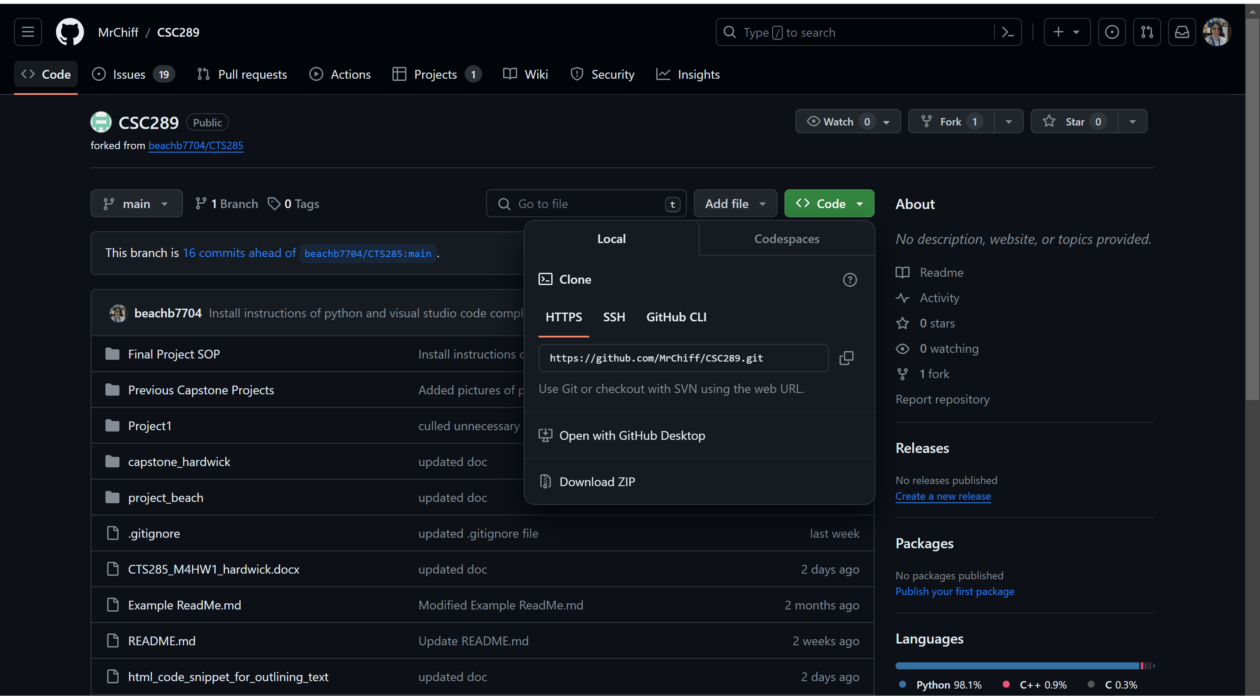

1. Click on Download ZIP, then select the location where you want the file downloaded if it brings up that option. If it does not, then it will download to your default folder for downloads.

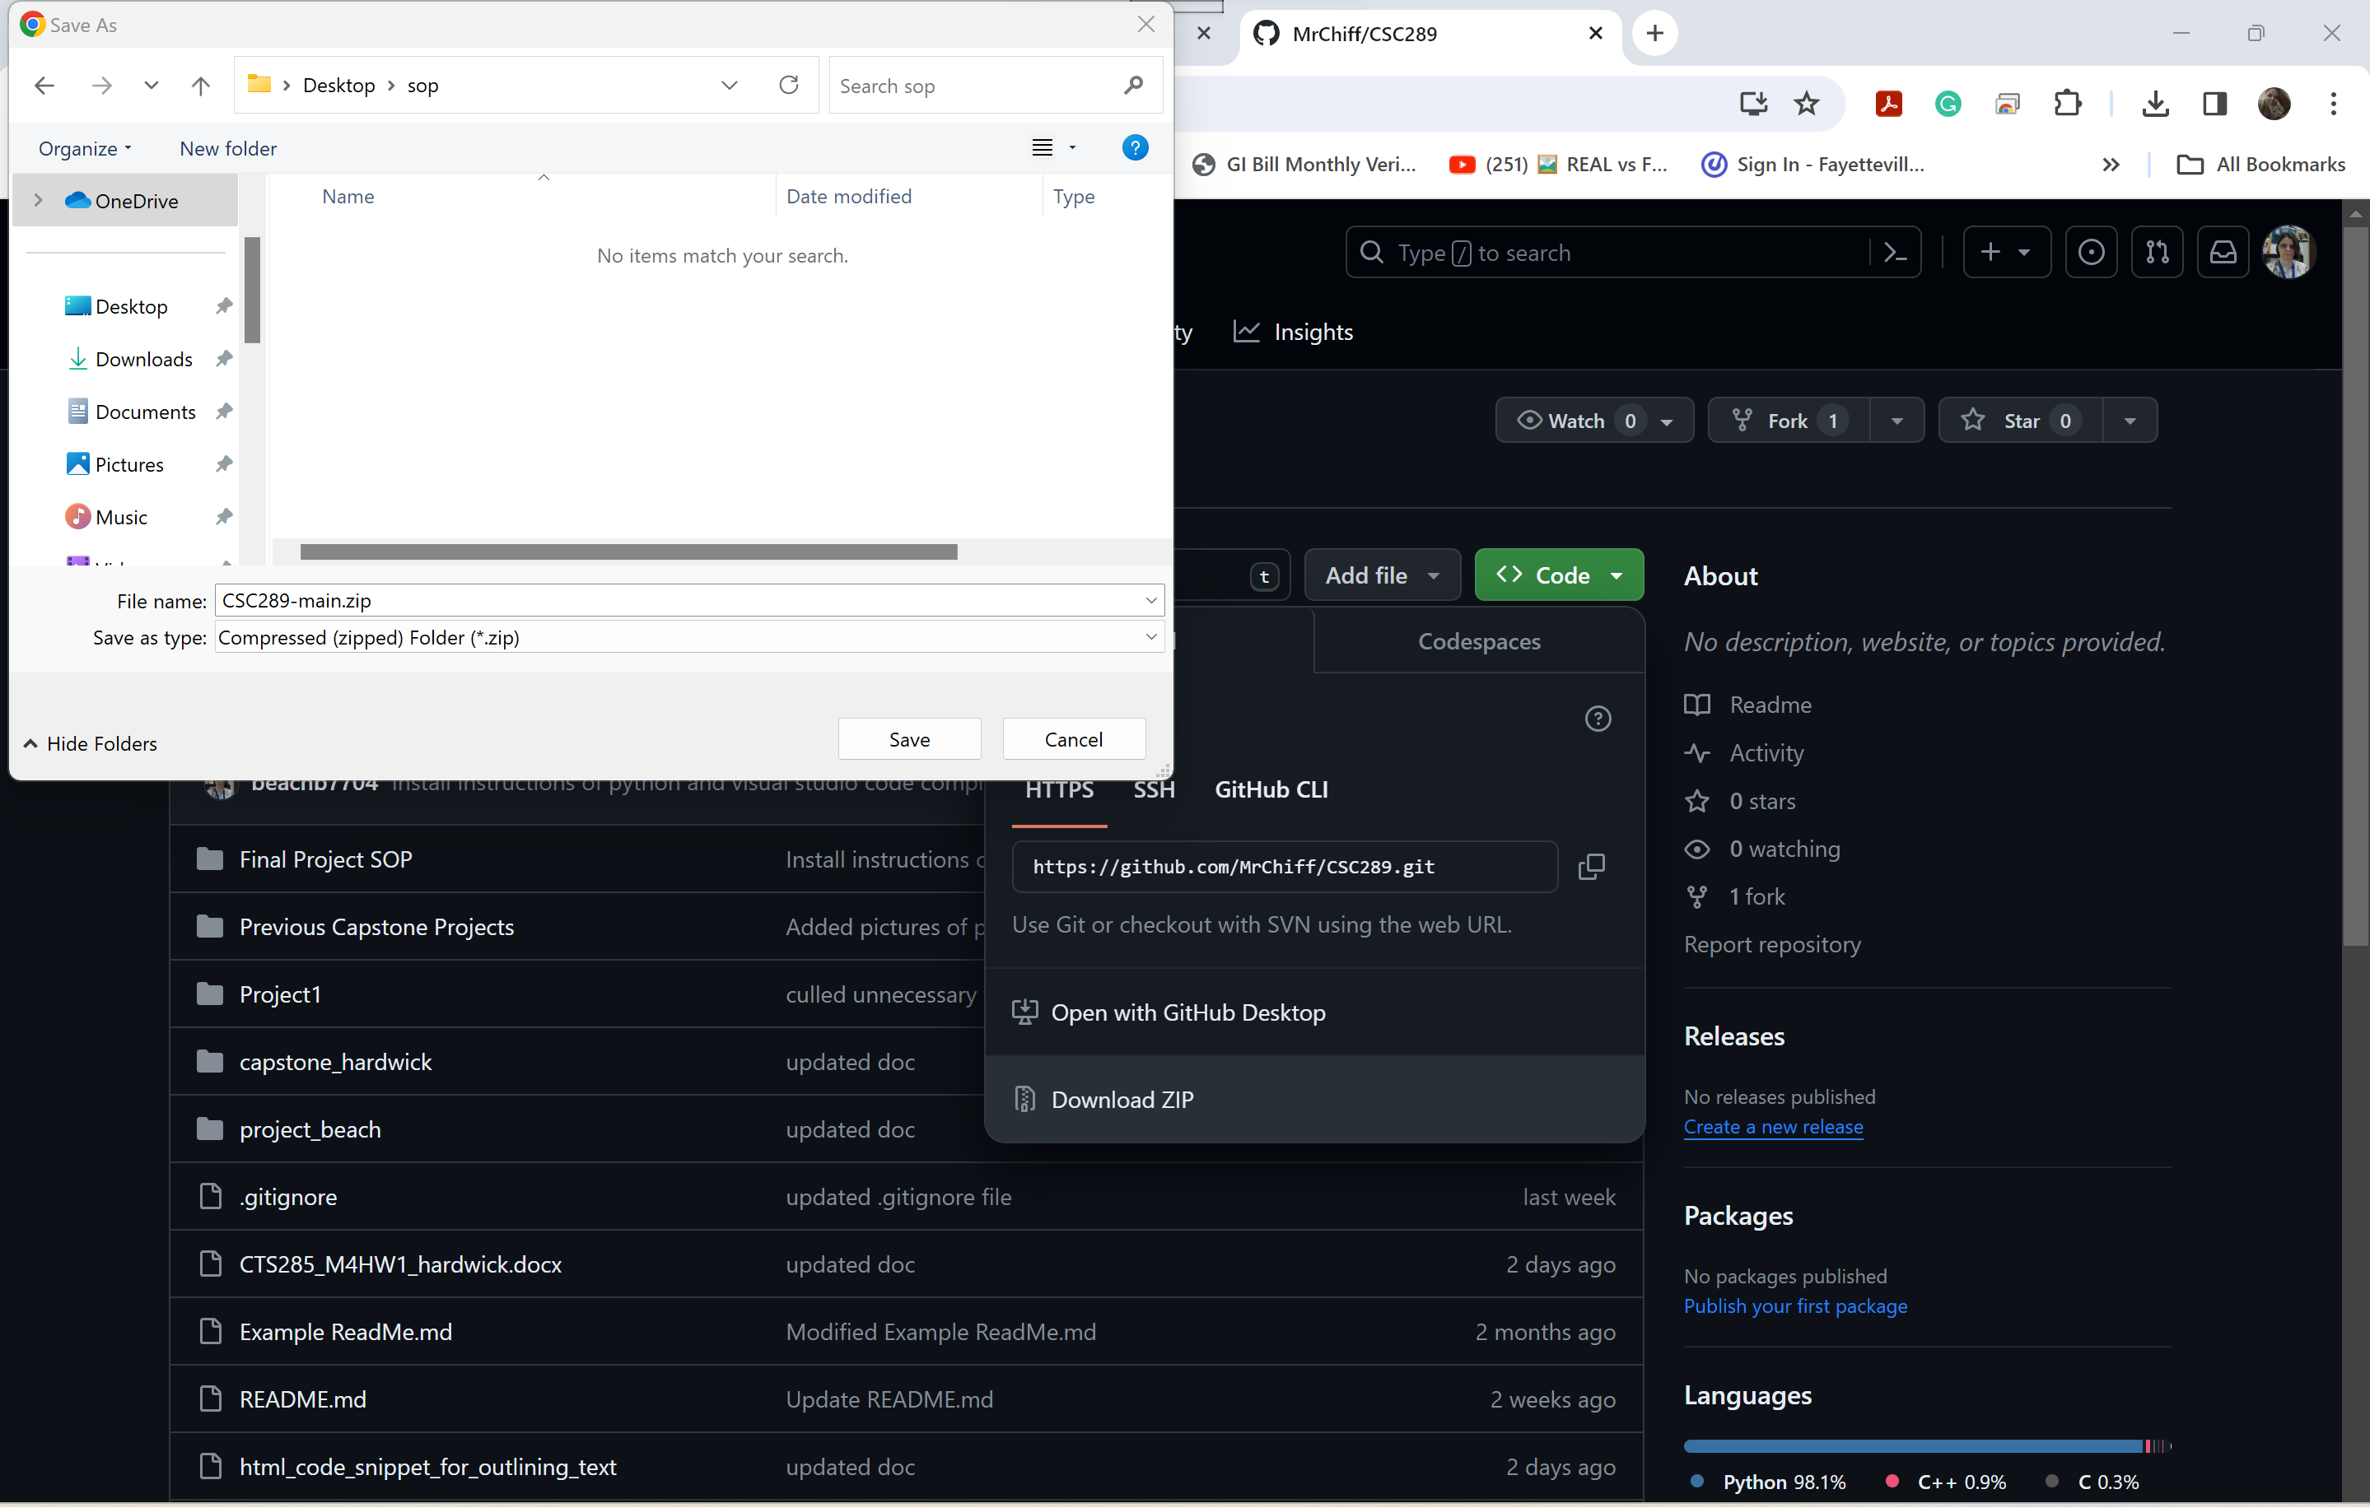

1. Open the folder to which you have saved the zipped file and right-click on it. Select Extract All so you can extract everything you have downloaded from GitHub.

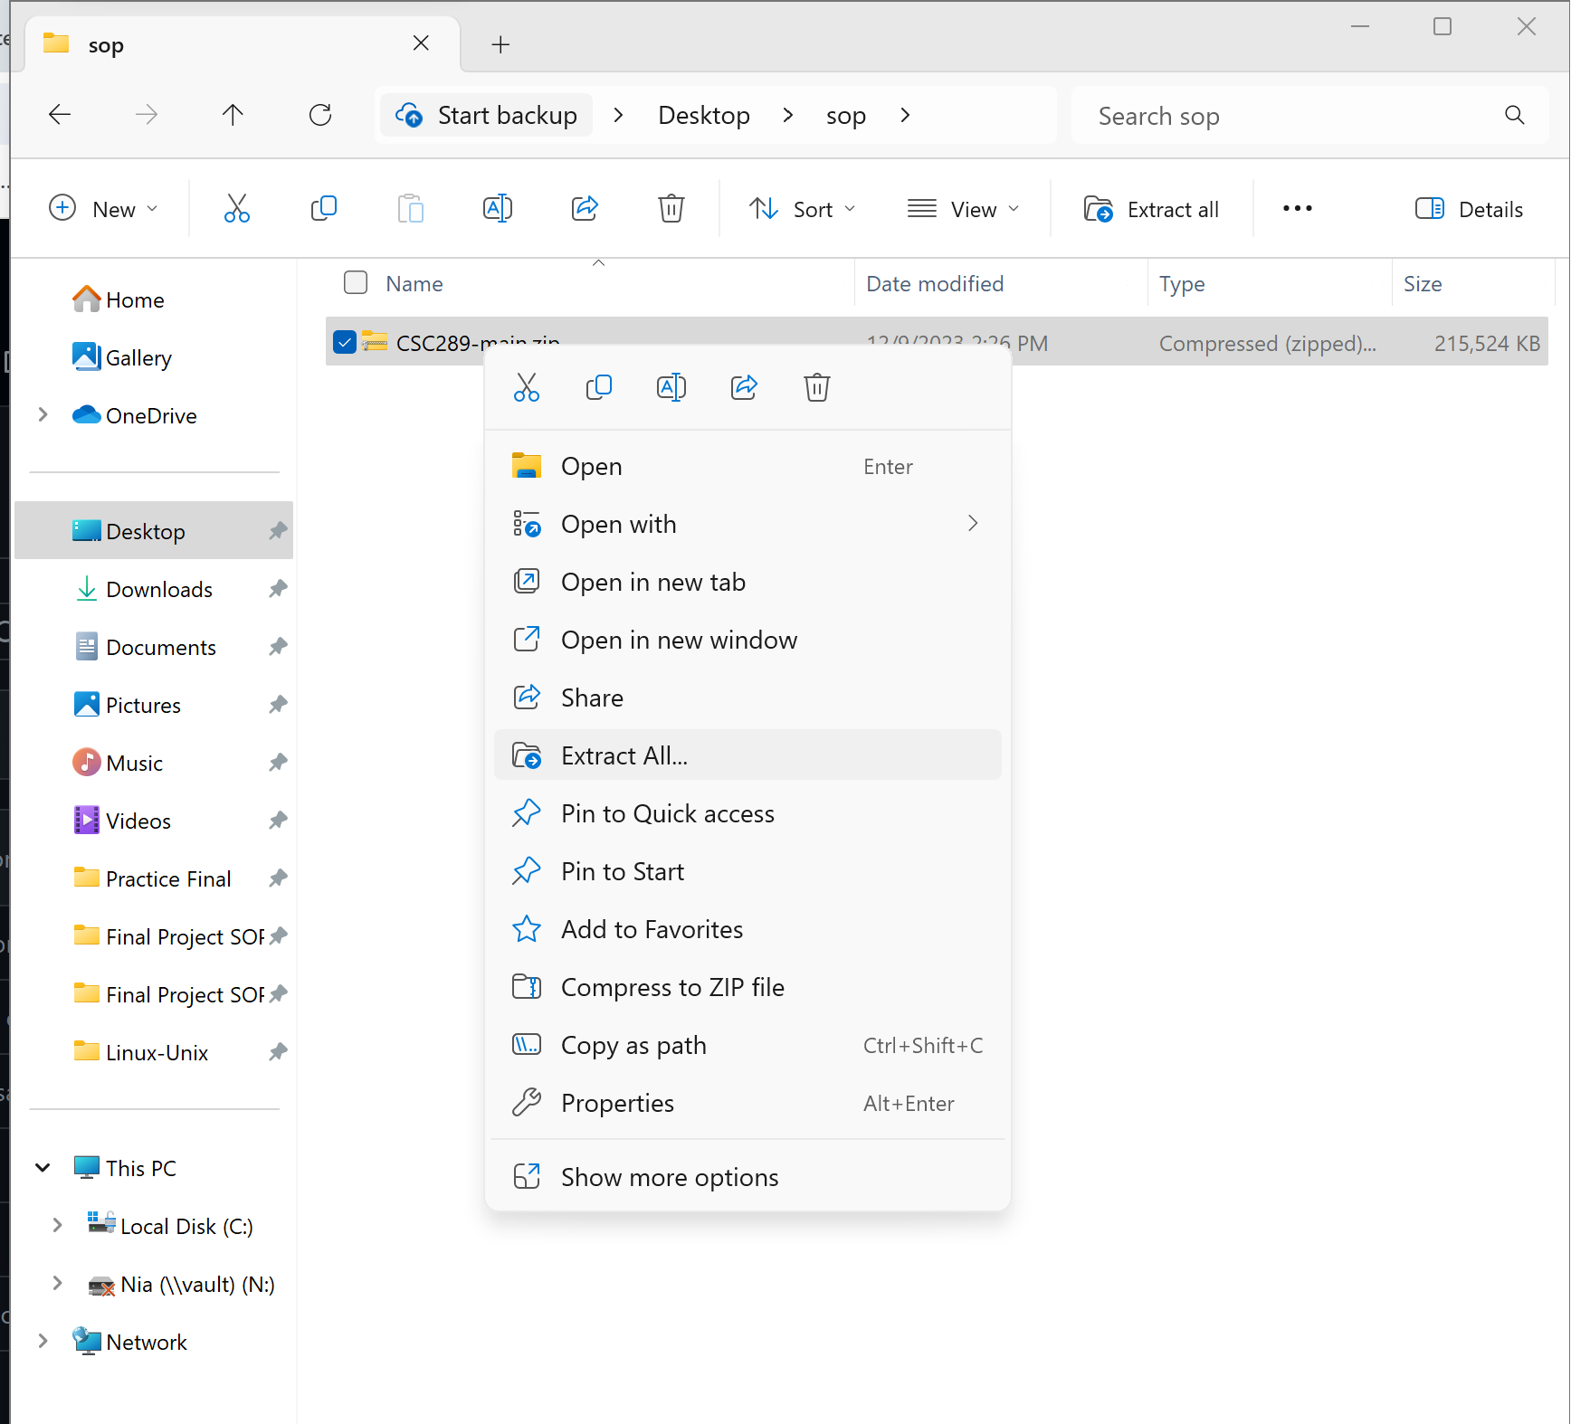

1. Select the folder to which you want to extract all the files, then click Extract.

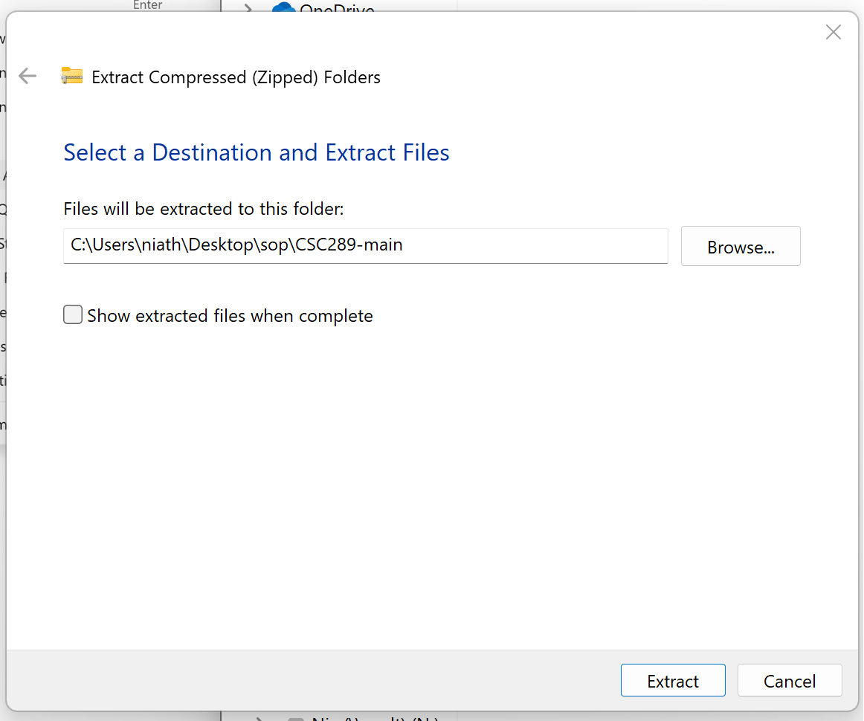

1. The files will now be extracted to that folder.

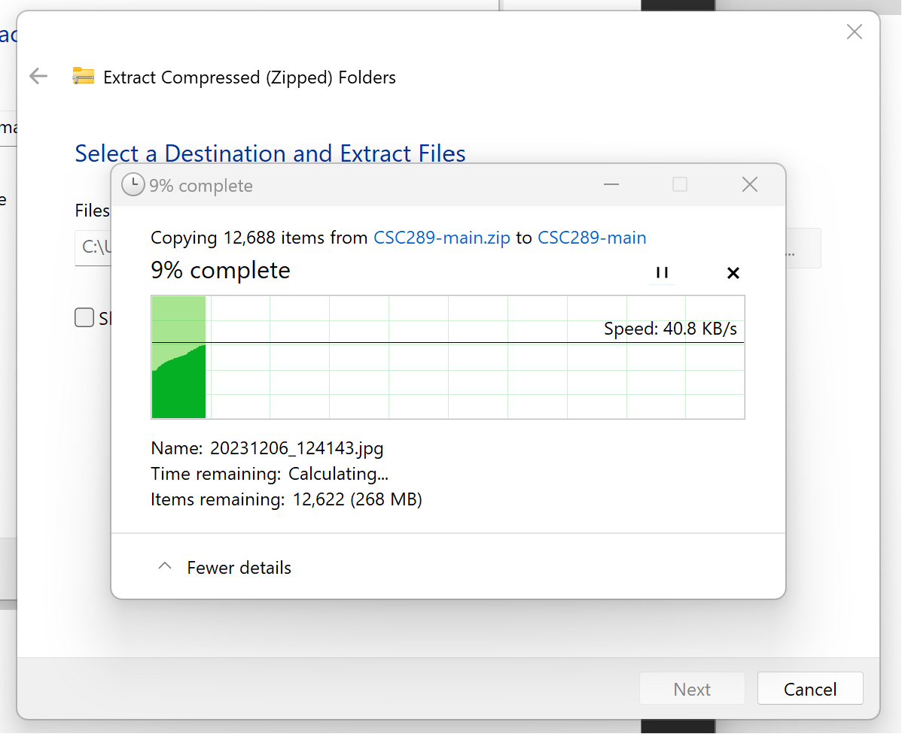

1. Once the files have been extracted, double-click on the new folder to open it and view the contents.

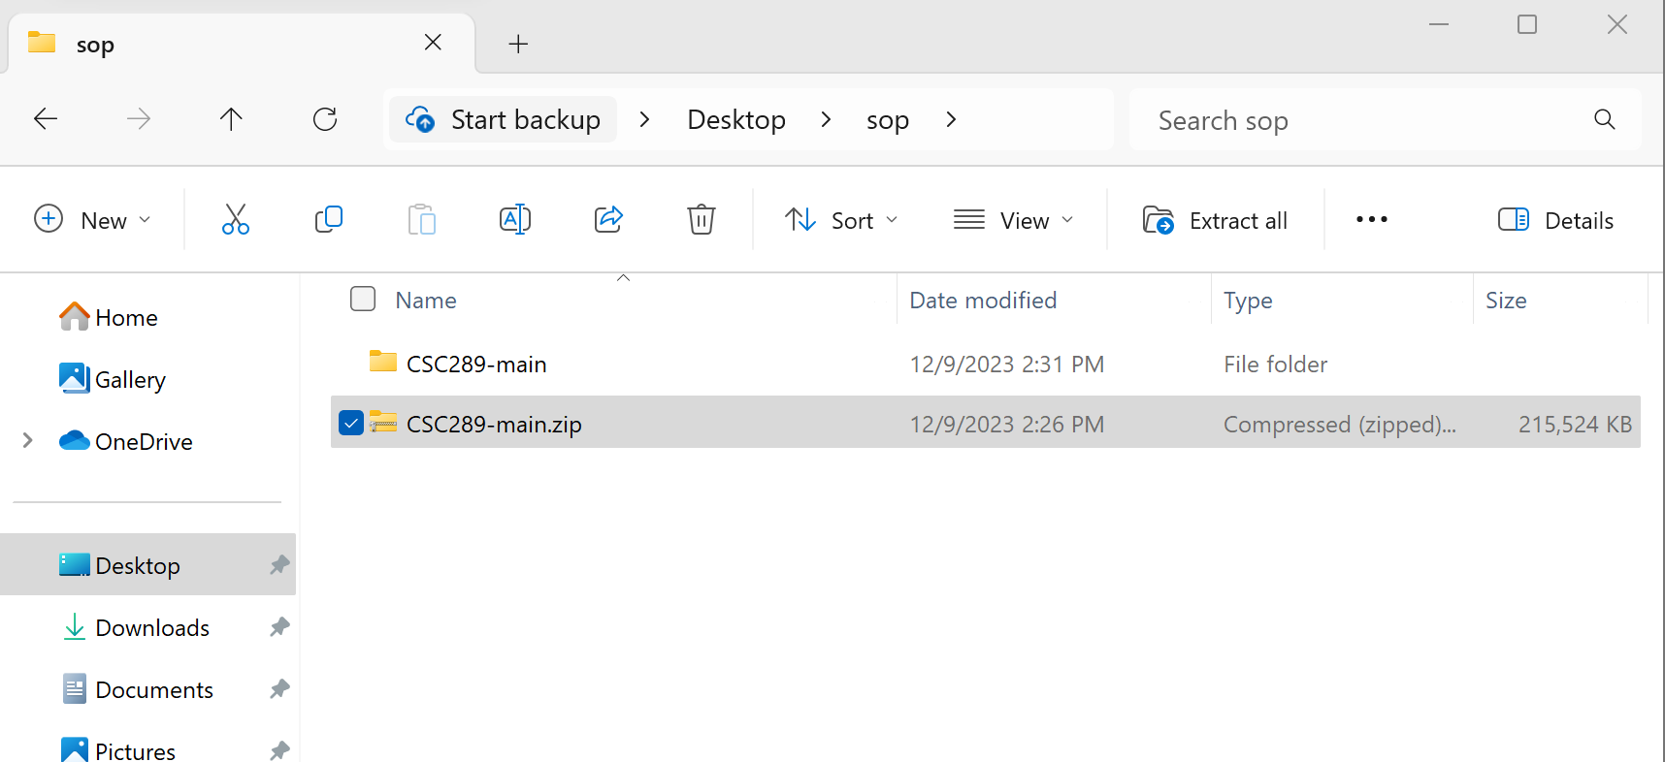

1. Double-click on the following folder to open it and view the contents.

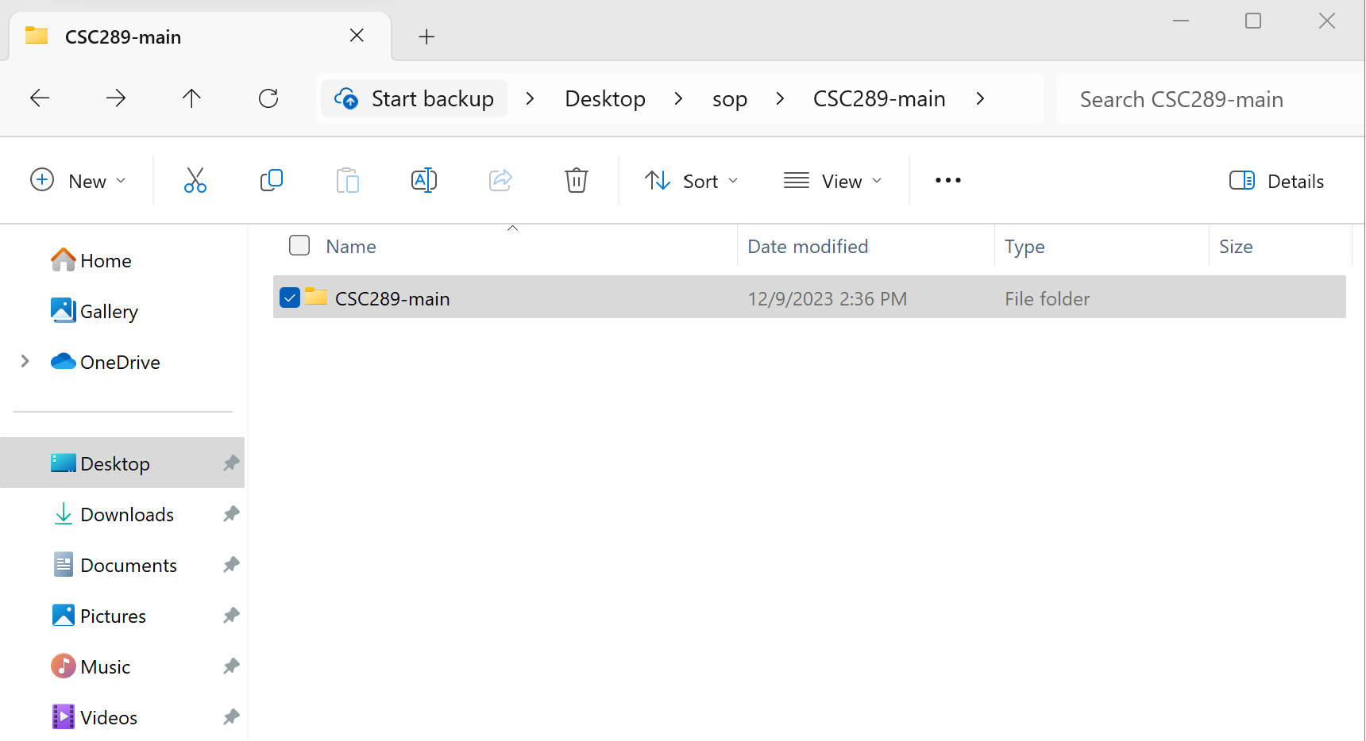

1. Now, you will verify that all files have been downloaded. Once verified, you can open the project inside Visual Studio Code and create your virtual environment.

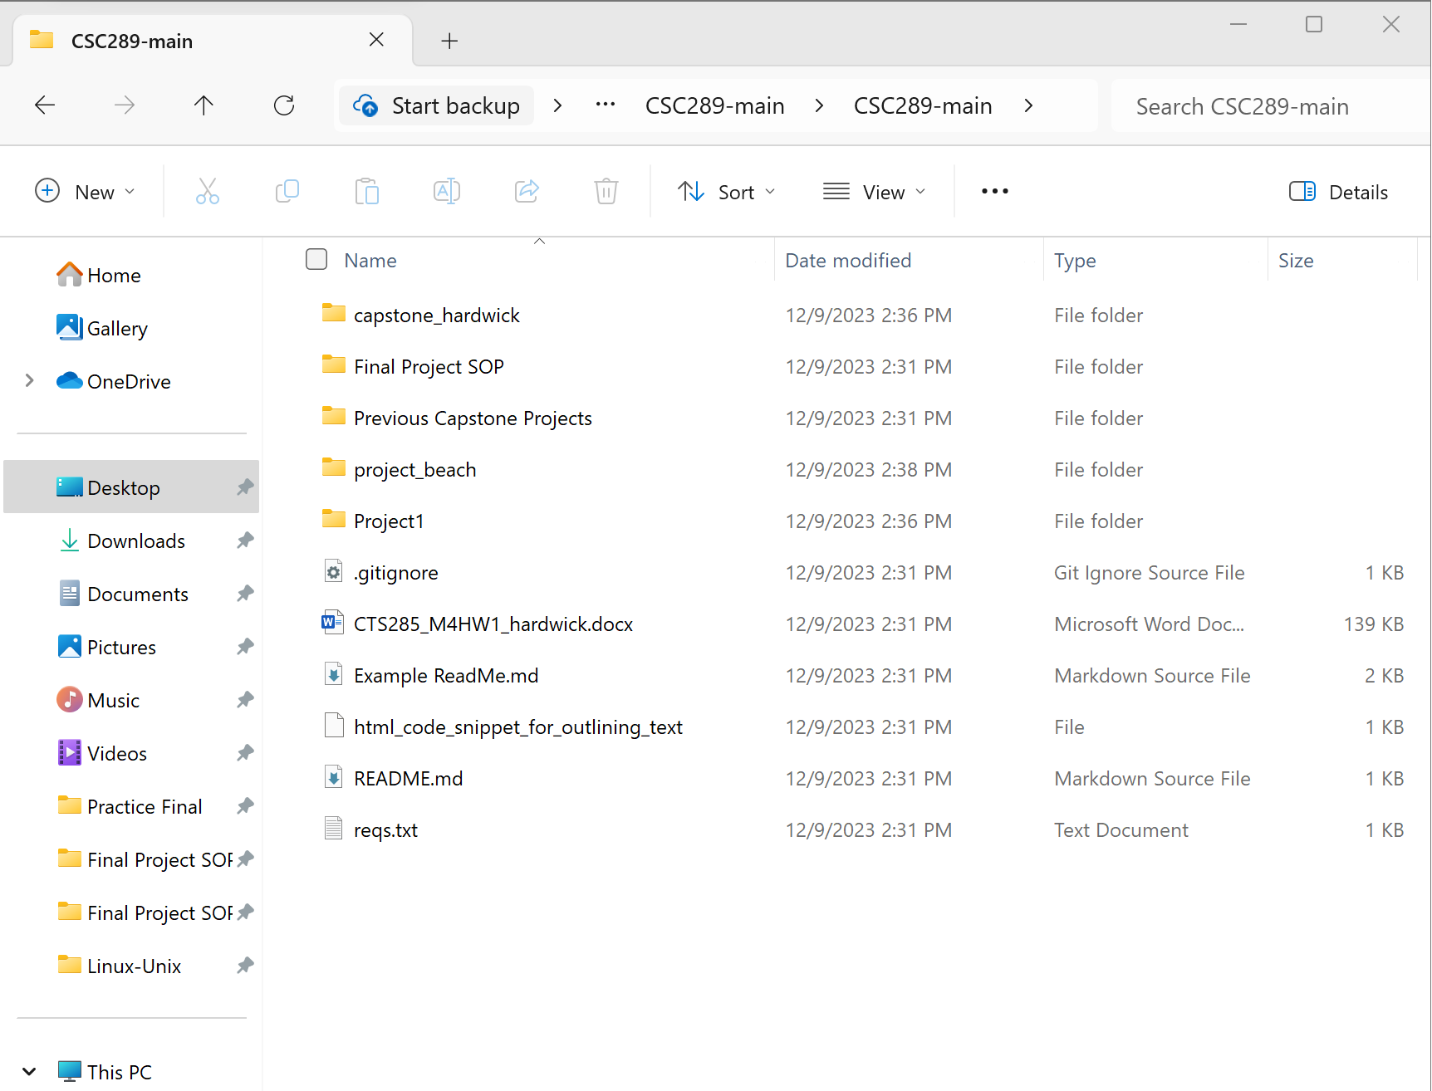

# **Open the Project in Visual Studio Code and Activate the Virtual Environment**

1. If you still have Visual Studio Code open from when you installed it, all you will need to do is click on File, then click on Open Folder.

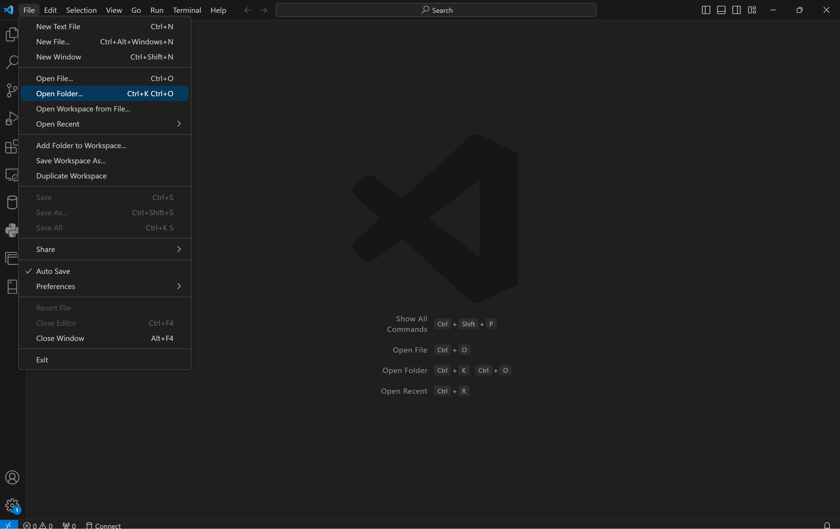

1. Navigate to the folder of the project you want to open. Only click on the main folder, then click on Select Folder.

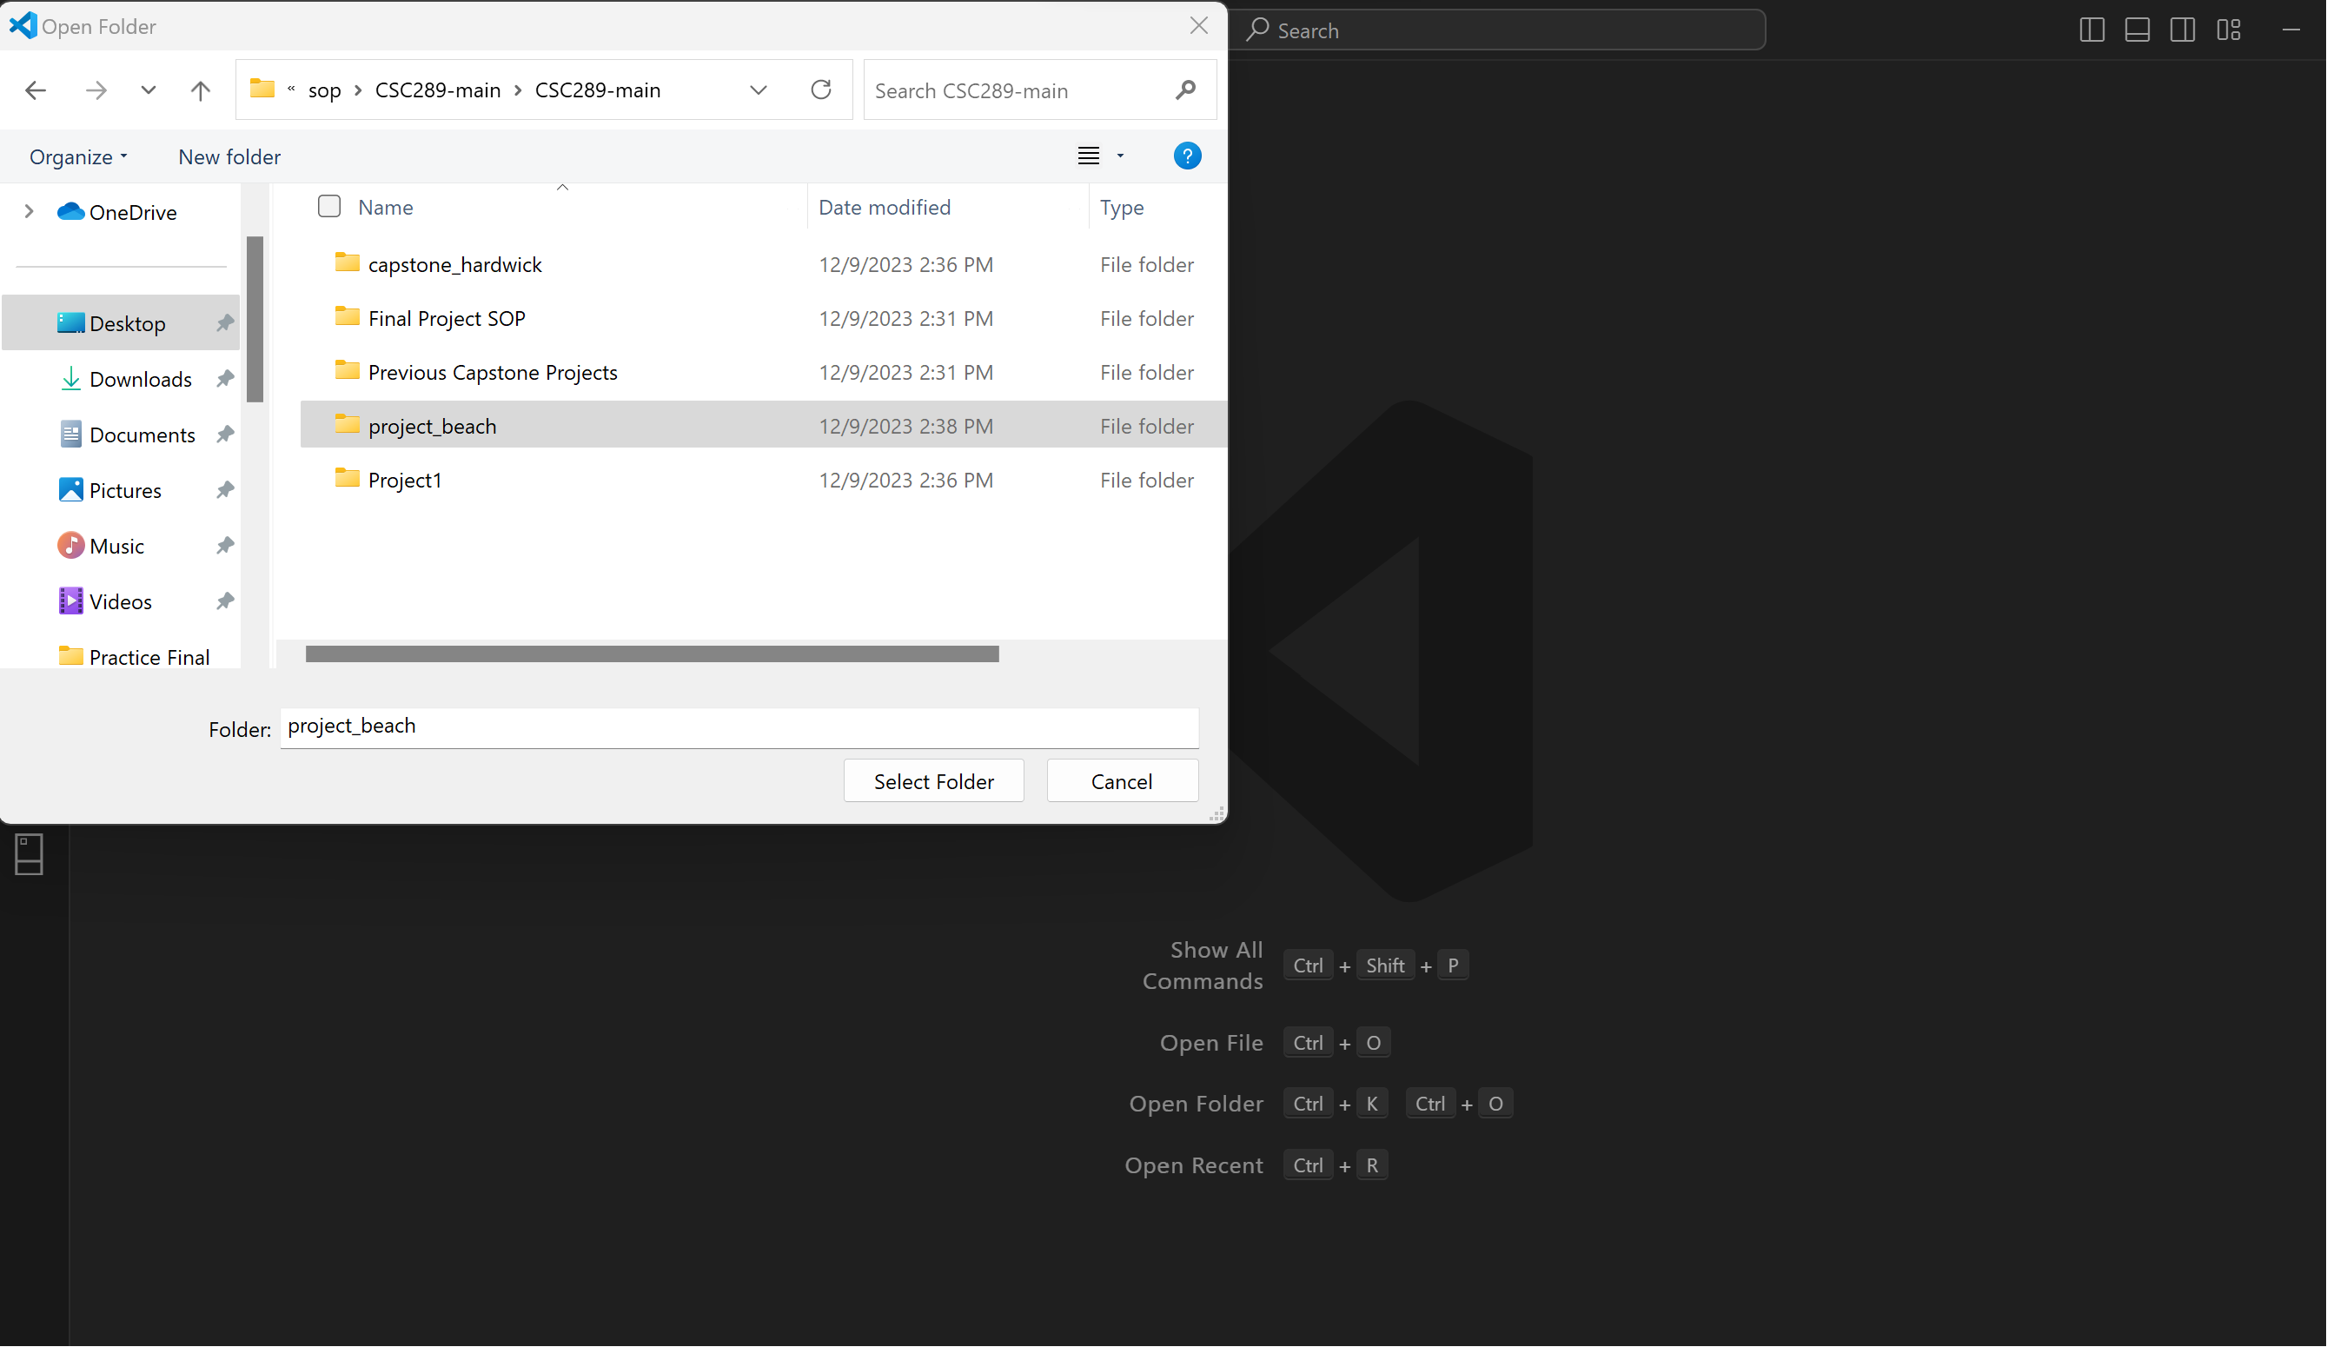

1. At the top of the screen, click Terminal, then New Terminal.

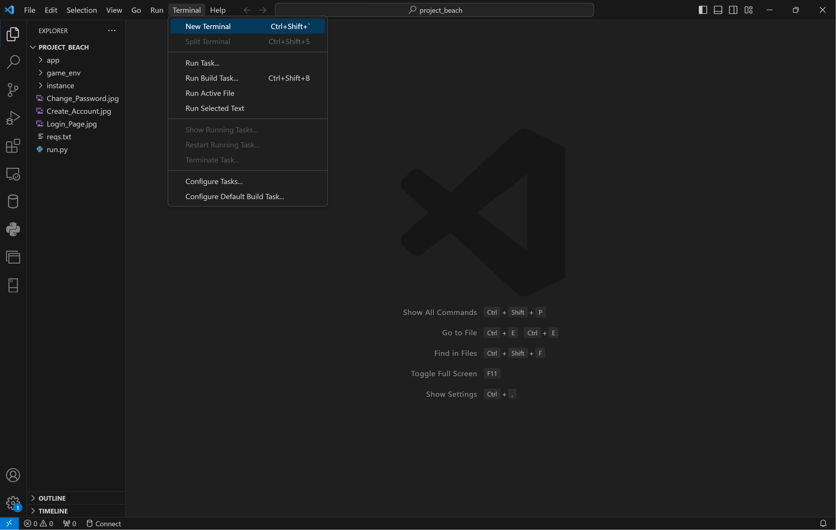

1. Click on the arrow by the plus symbol, then click on Command Prompt to open a command prompt where we will create our virtual environment.

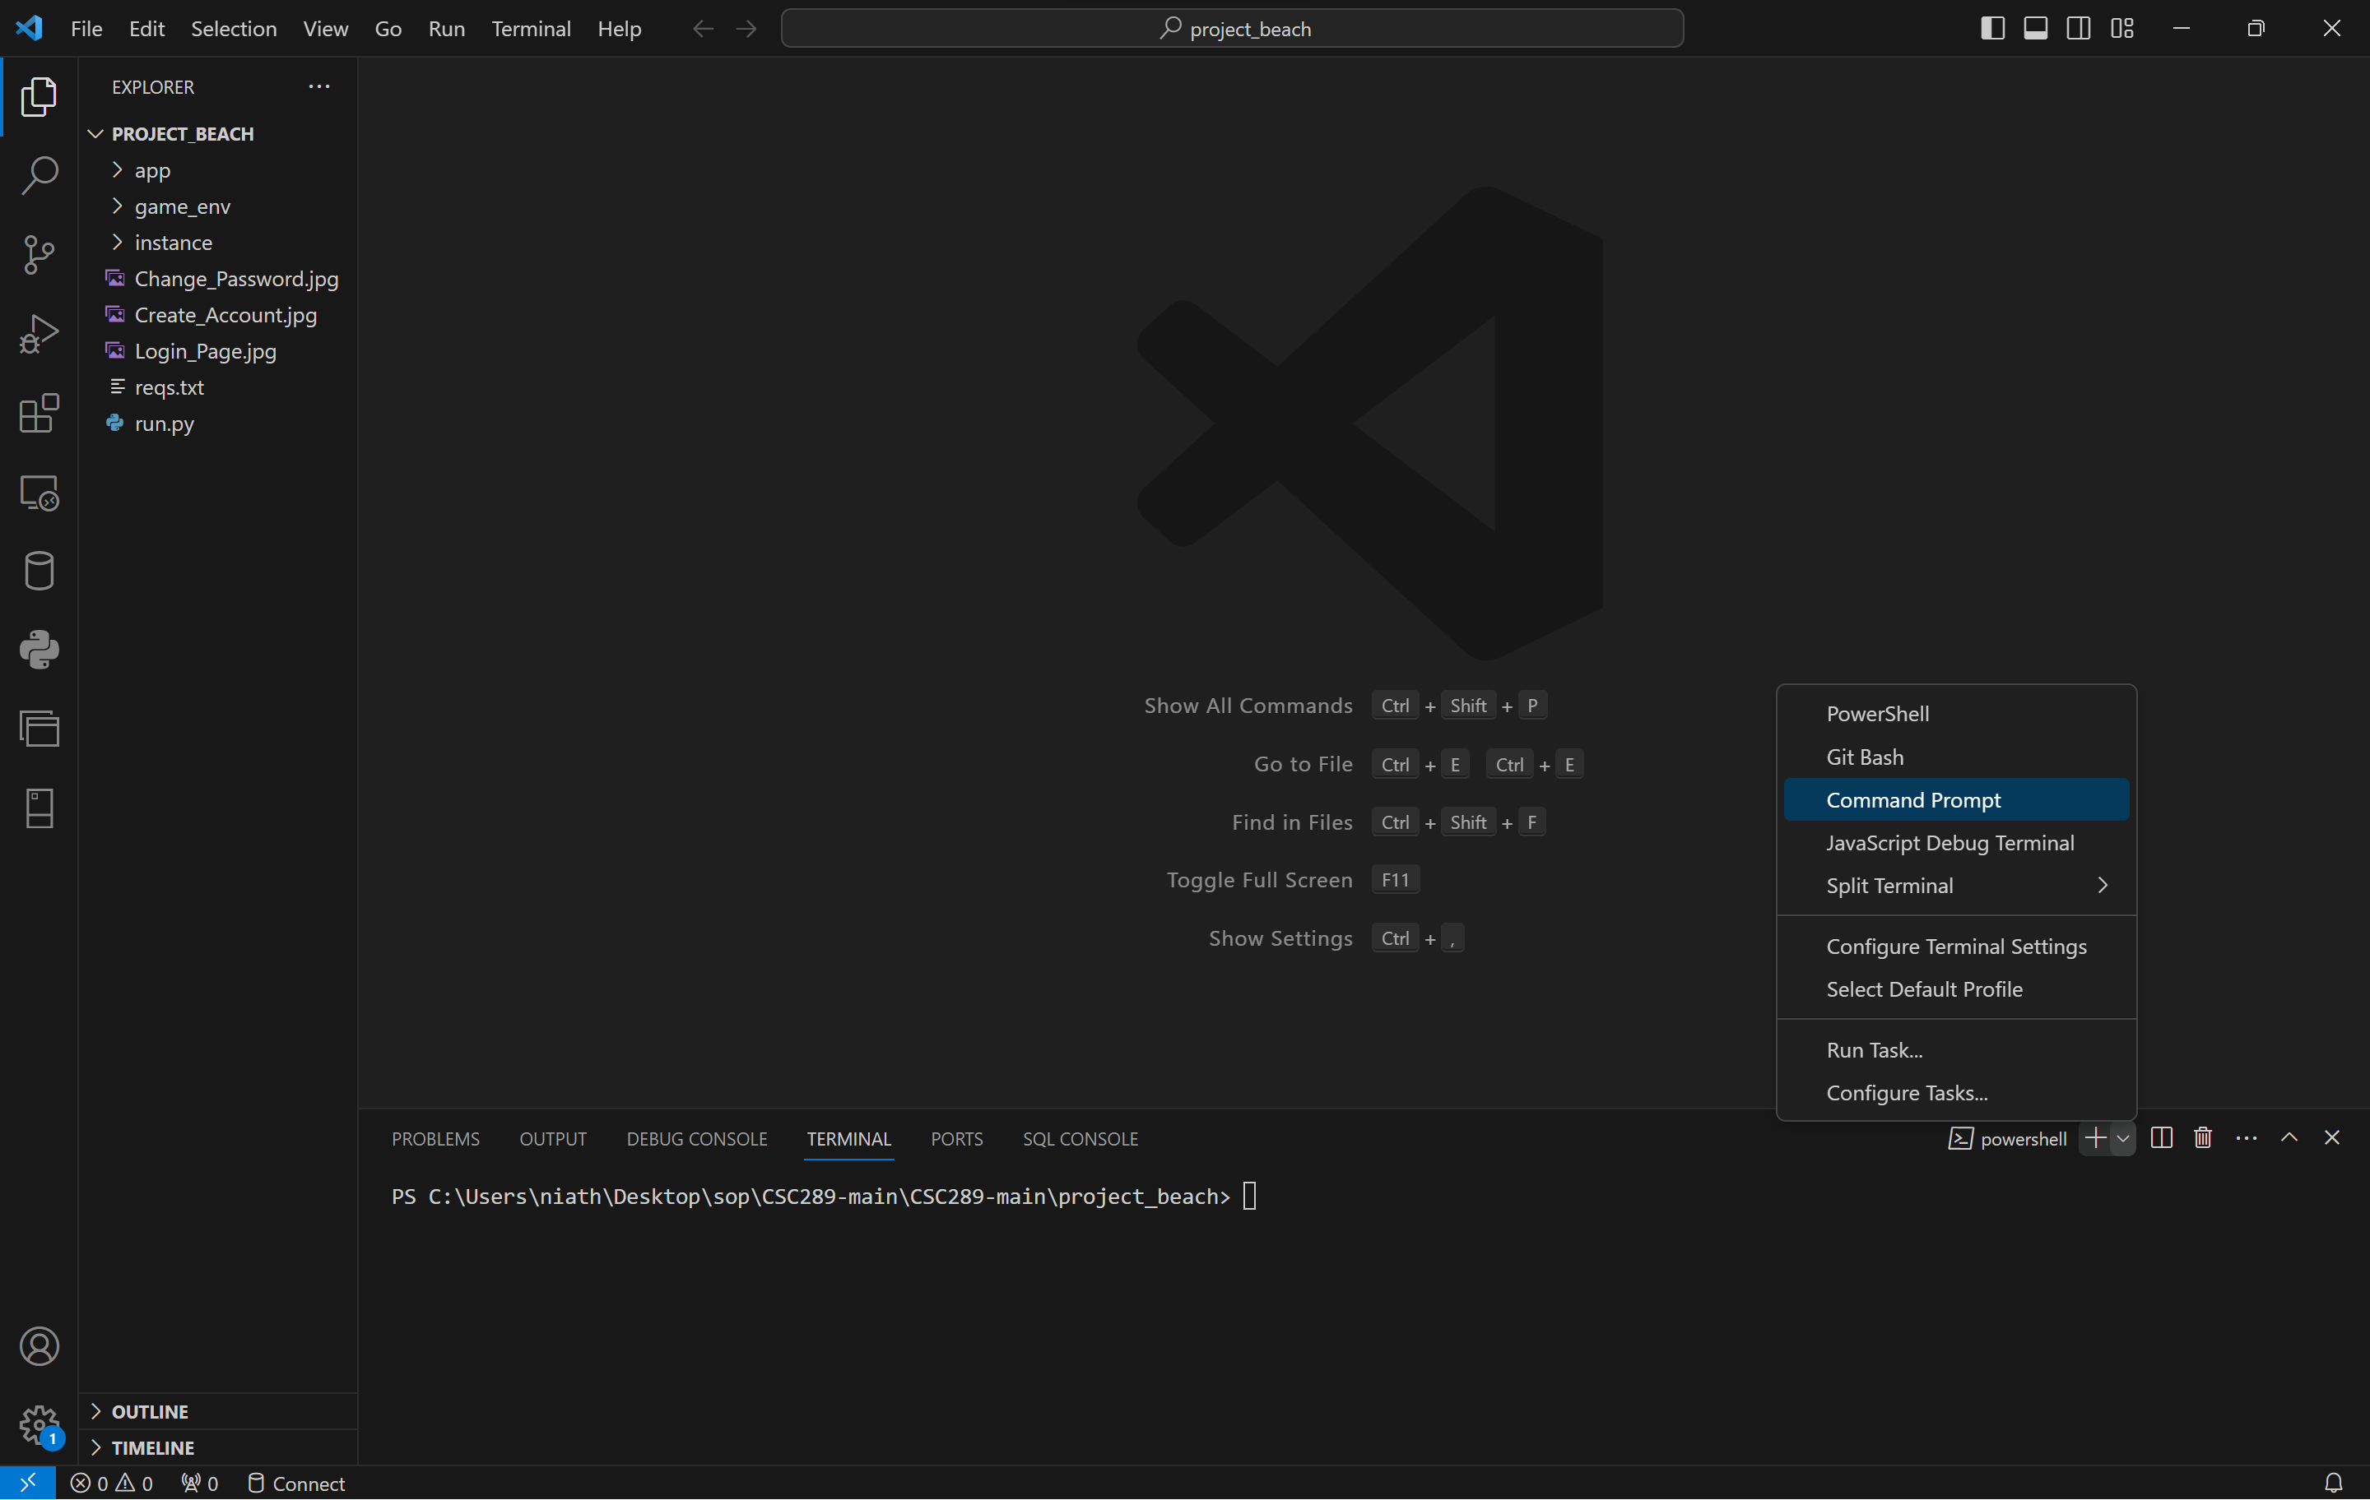

1. Now, we need to remove the Power Shell terminal by clicking on the trash can icon next to the Power Shell terminal.

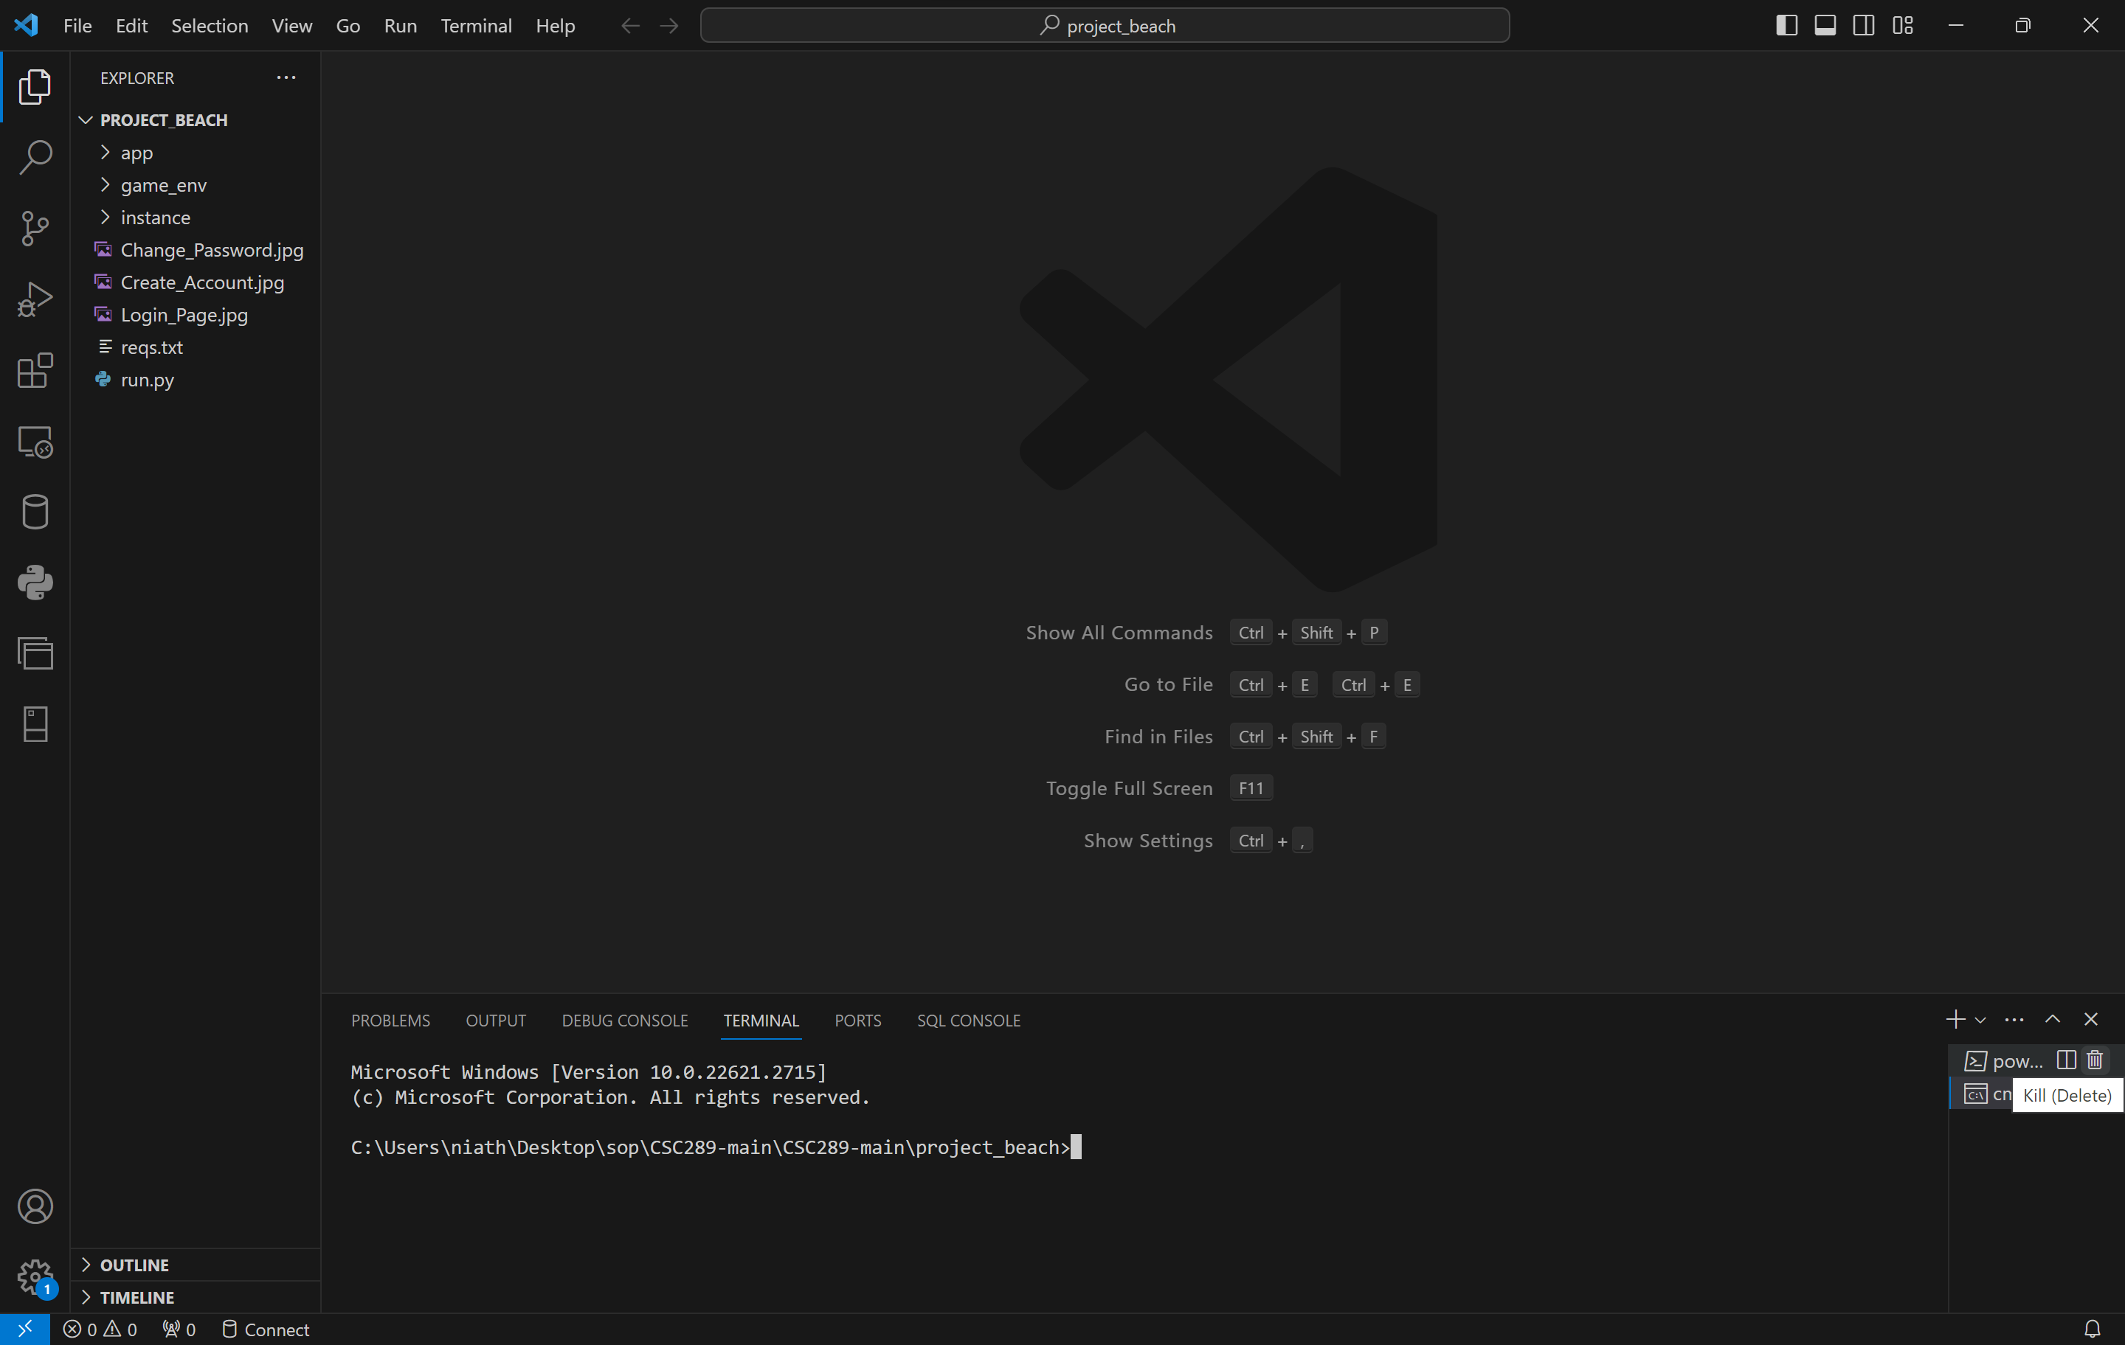

1. Use the command python -m virtualenv “your environment name.” An example would be:

python -m virtualenv vgls_env

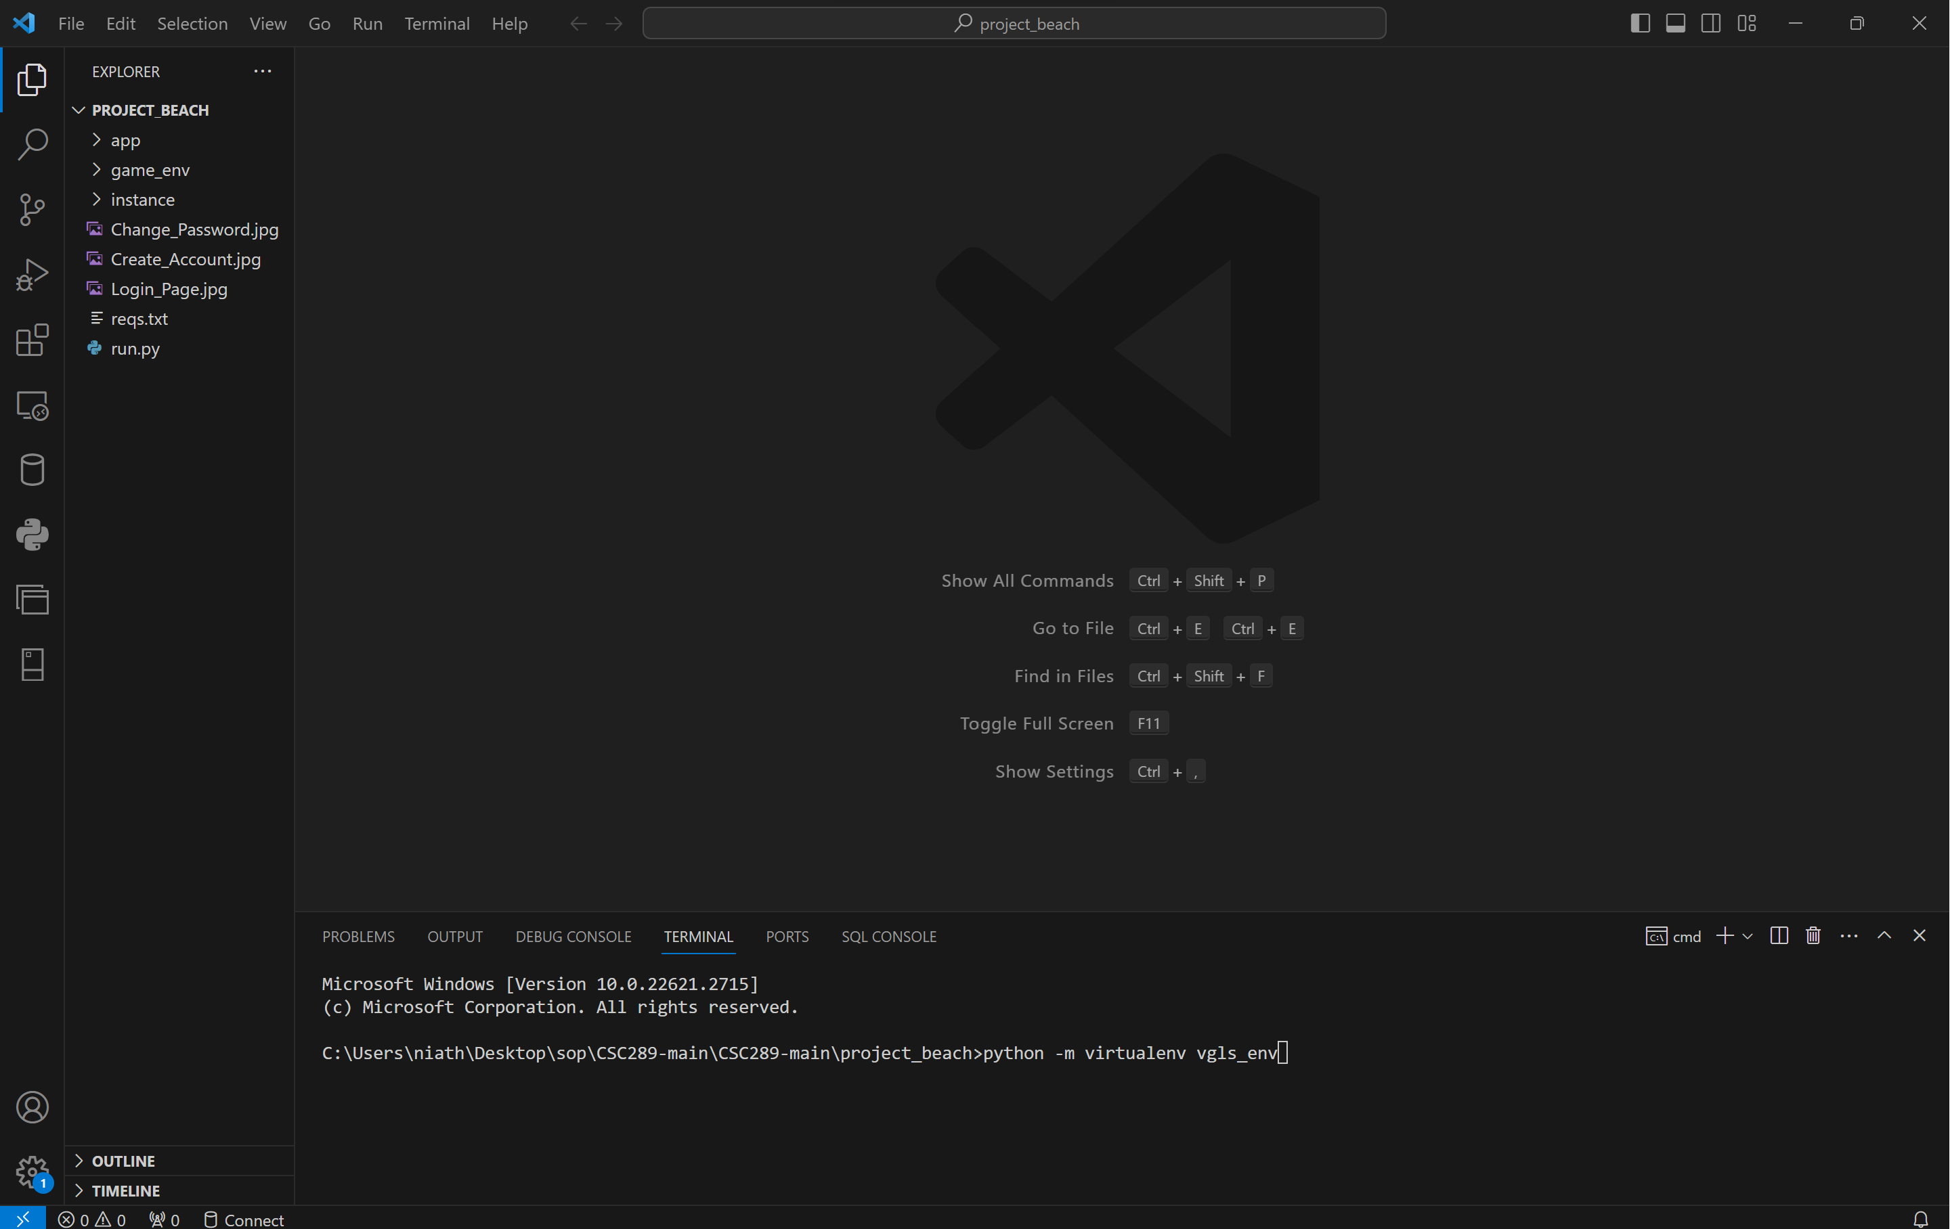

1. Once you press Enter, it will create the virtual environment, and the folder will populate on the left side of the screen.

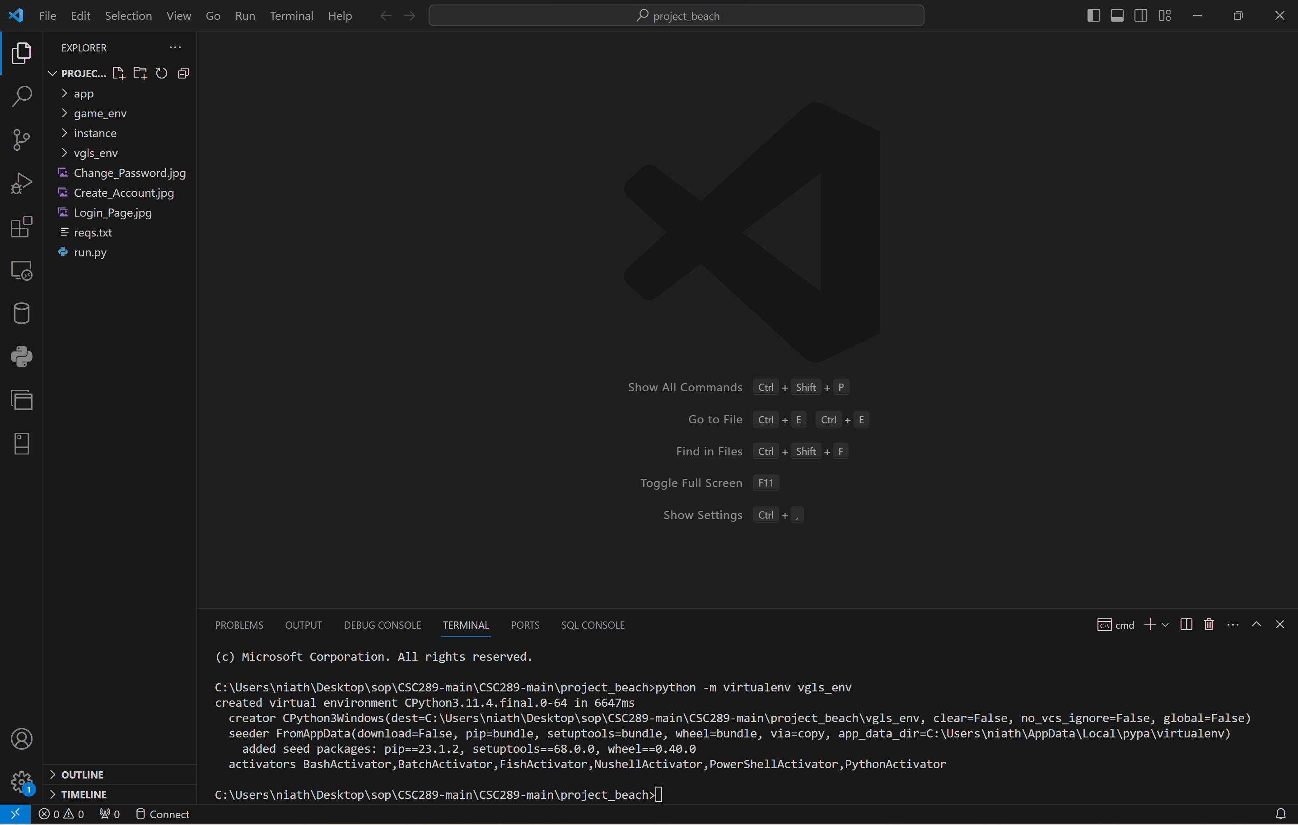

1. You must type “your environment name”\Scripts\Activate. An example would be:

Vgls_env\Scripts\Activate. You will then see the virtual environment name within these brackets(). This will let you know that you are now in your virtual environment.

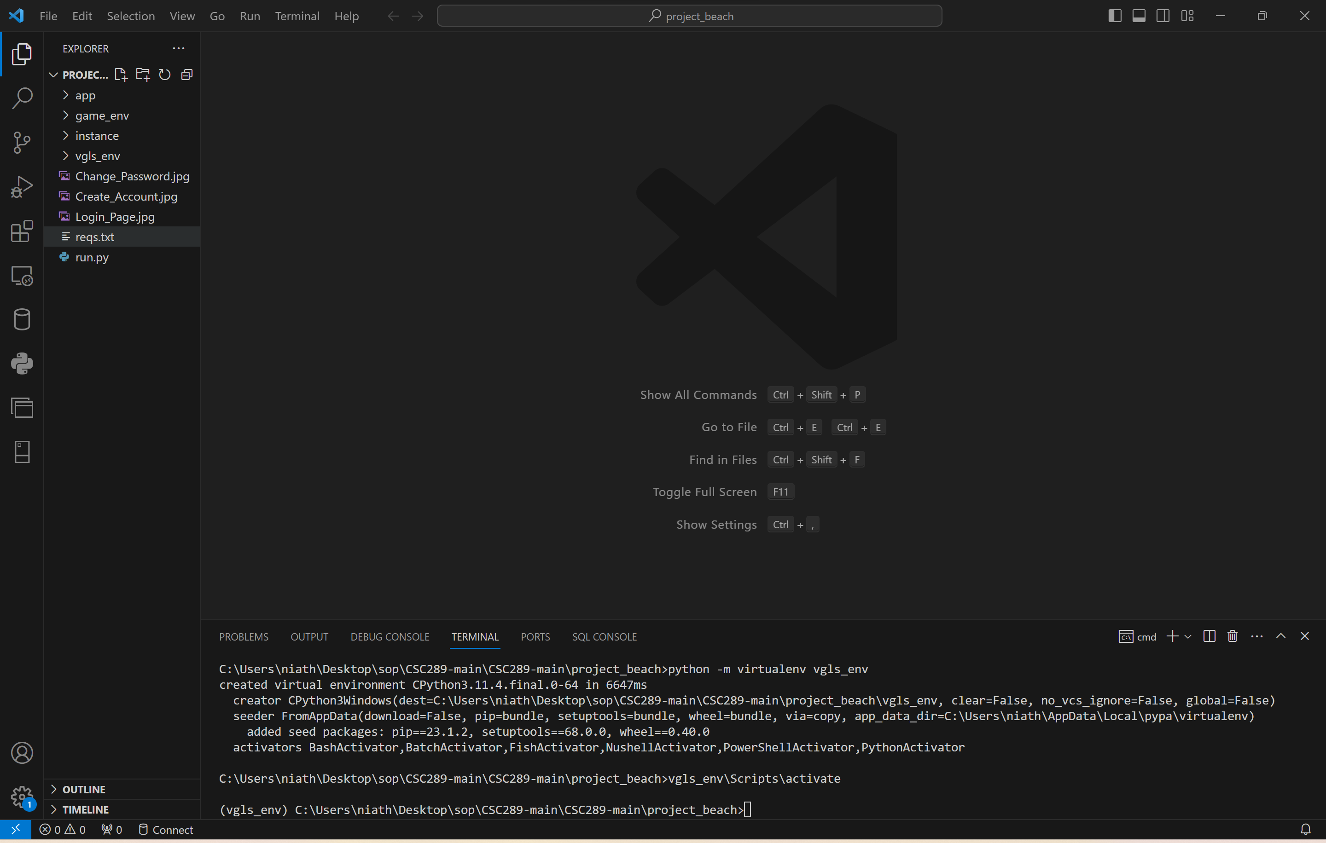

# **Install All Necessary Modules inside the Virtual Environment**

1. Type the following command pip install -r reqs.text. The reqs.text is the file name with all the modules required to run this program. You may get an error if a newer version of pip has been released.

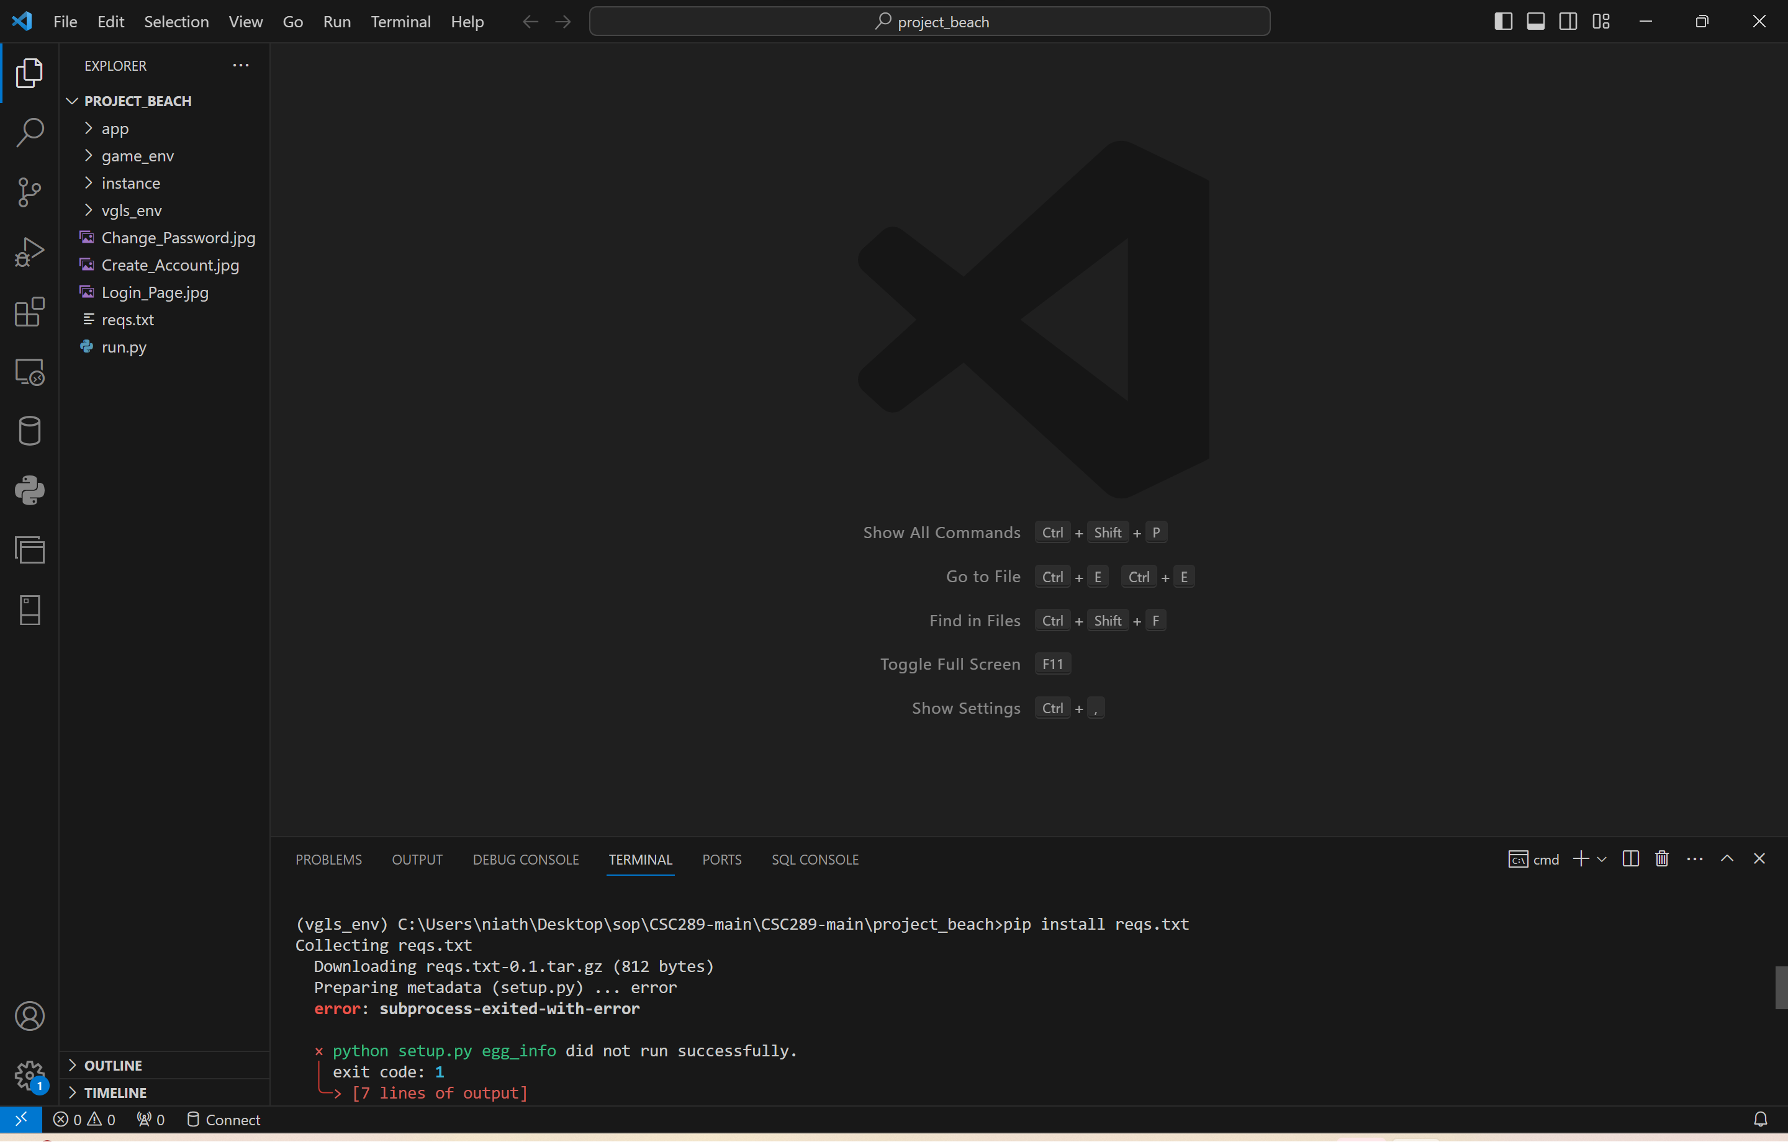

1. If you get an error, you will type the following command: python .exe -m pip install –upgrade pip. This will install the latest version of pip into your virtual machine. Then try again with the pip install -r reqs.txt to install all the needed files.

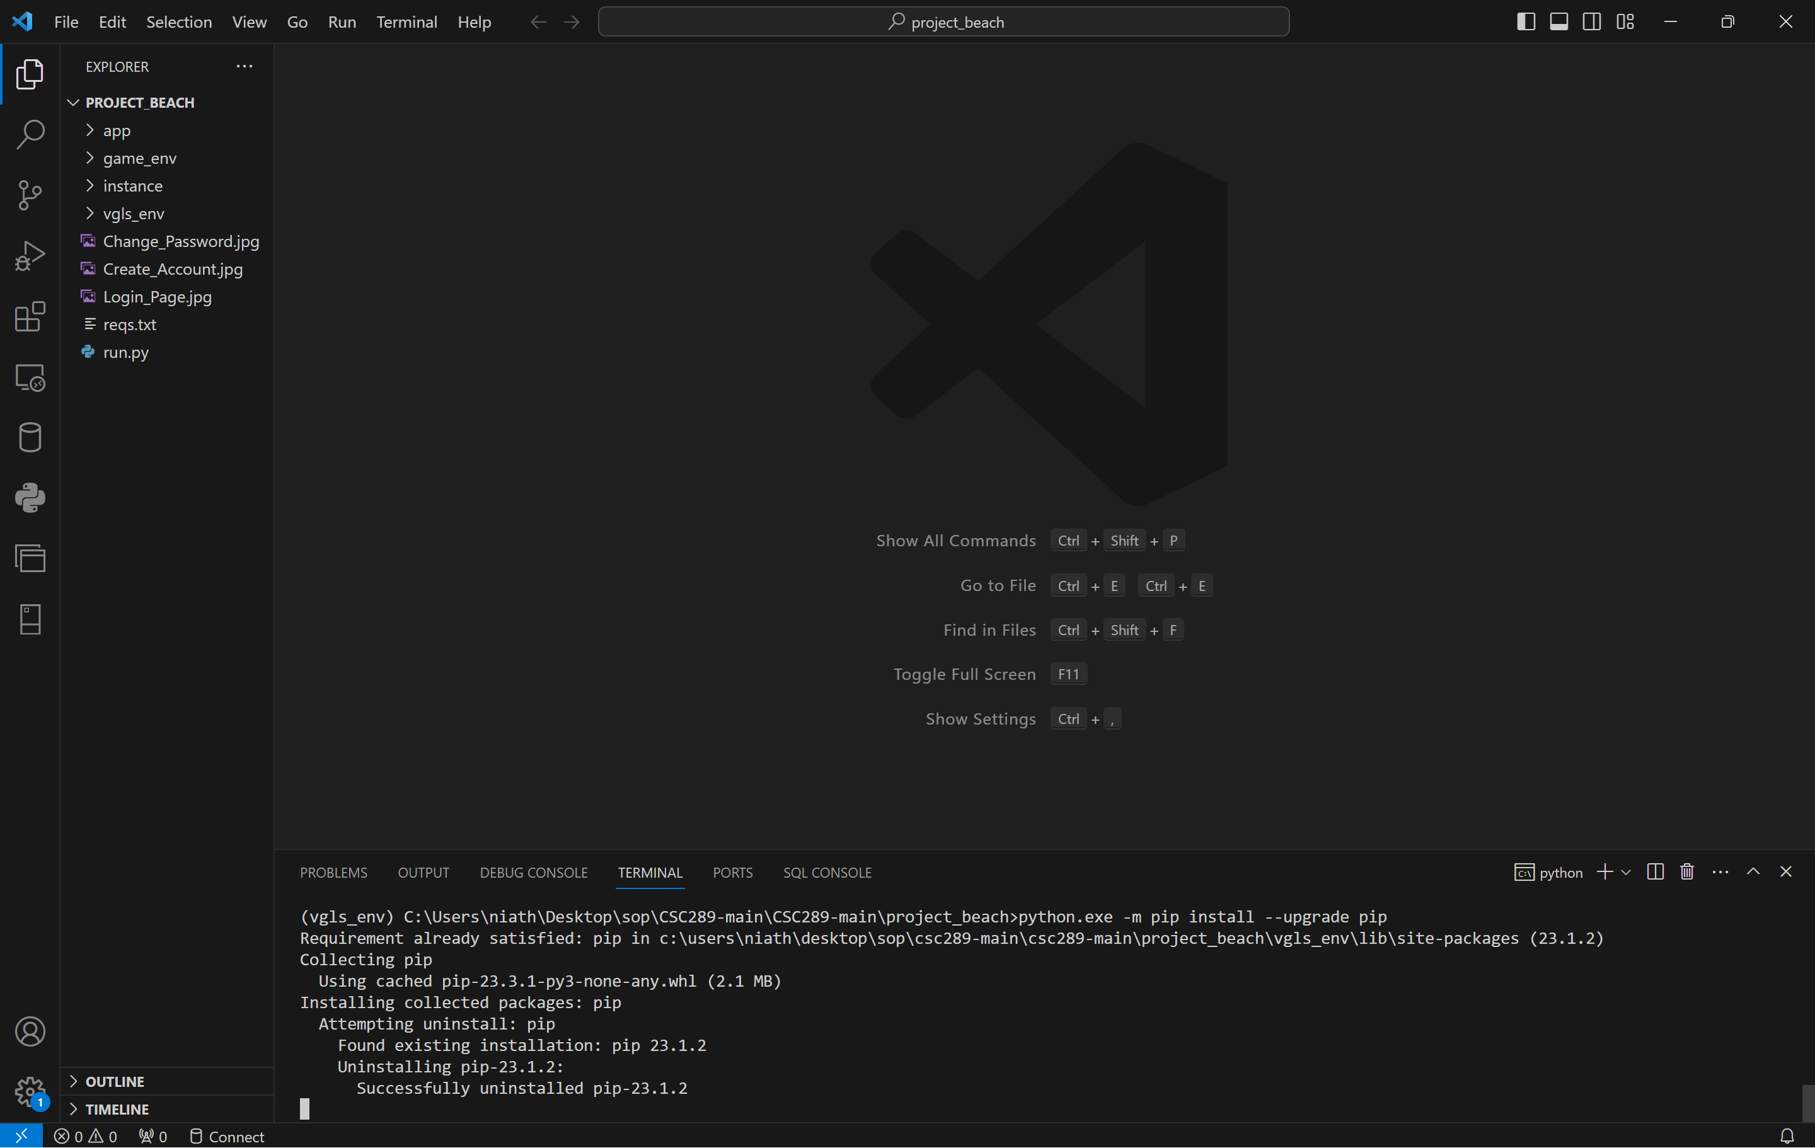

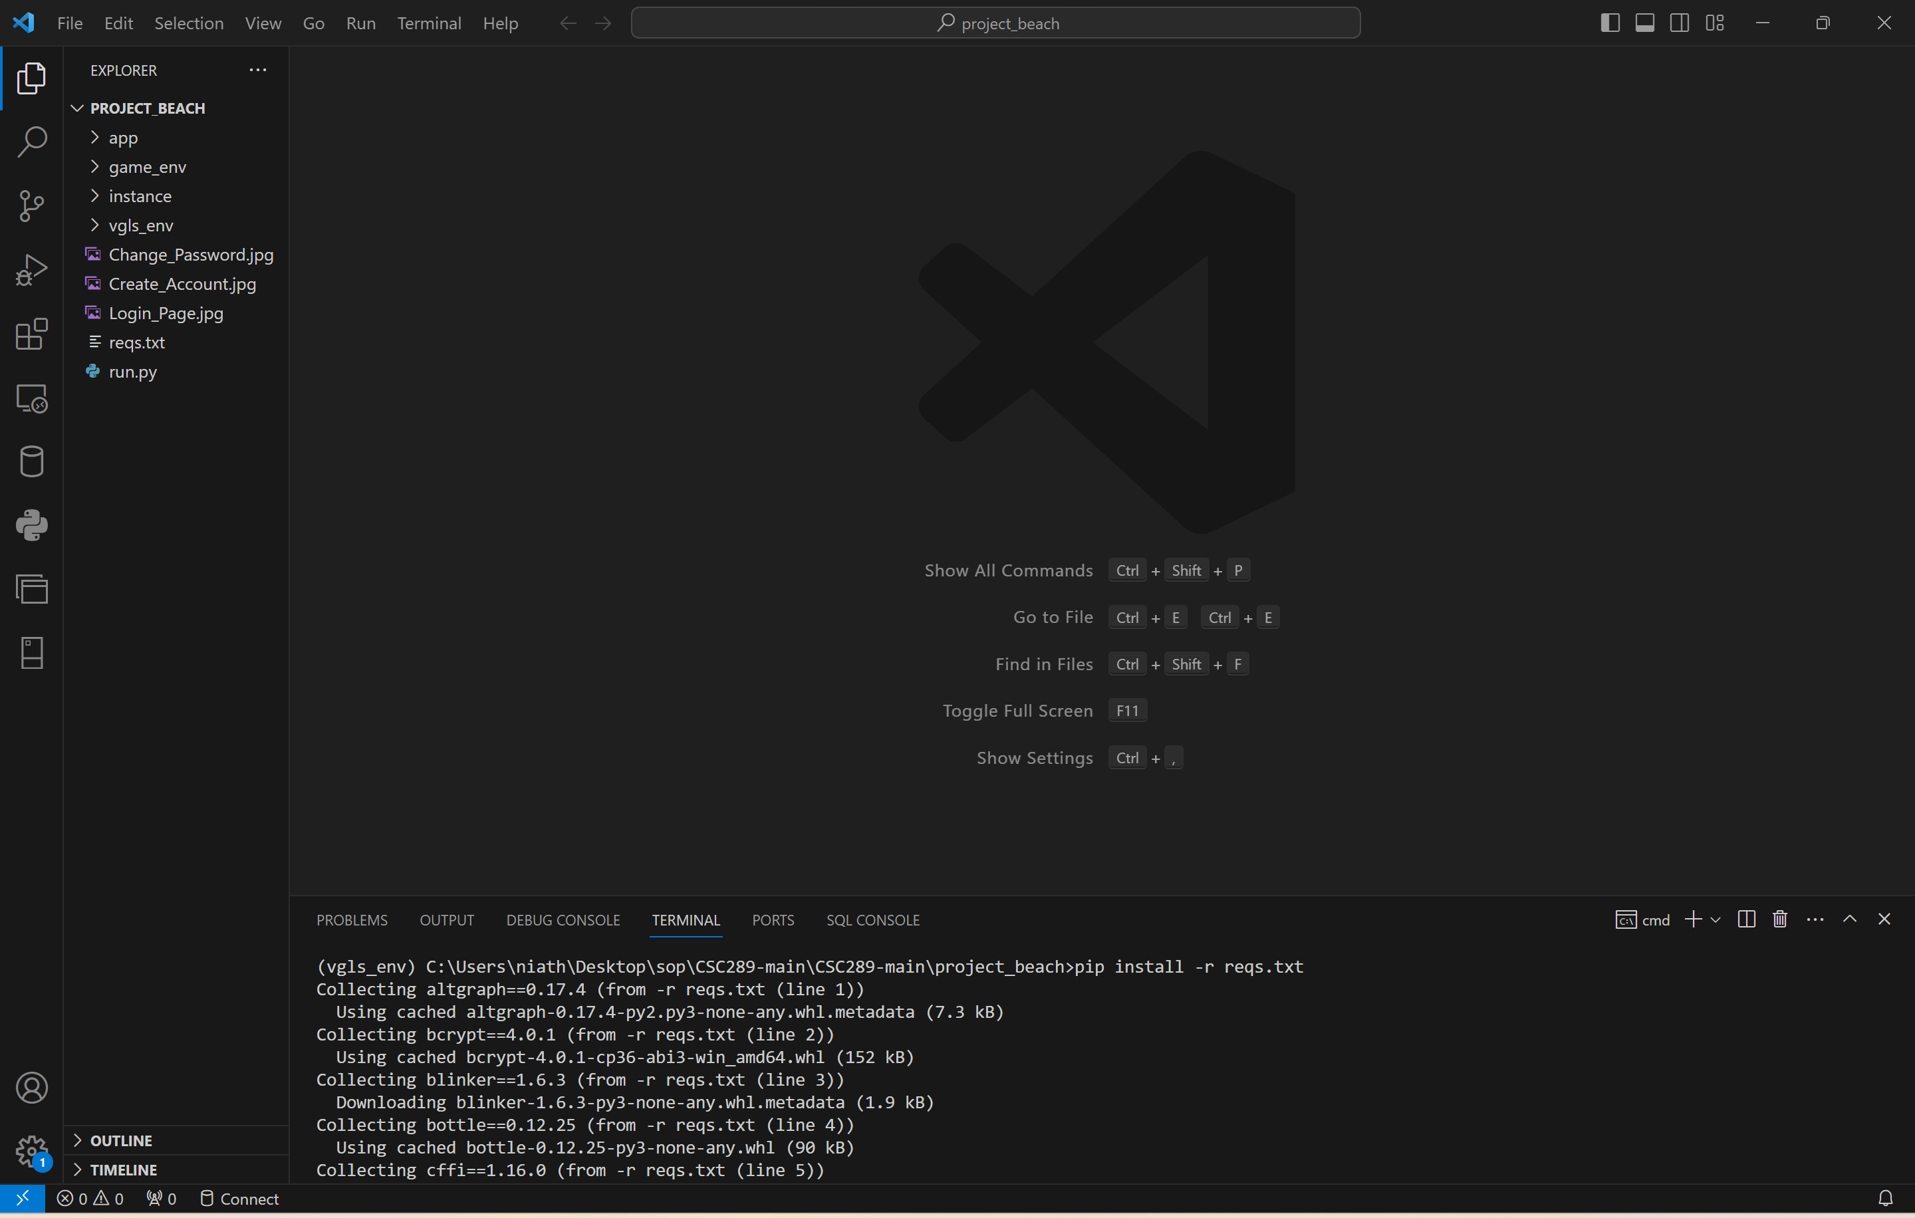

1. To verify that all of the files are downloaded, you will type pip freeze, then press the Enter key. It will then show all of the modules that are installed.

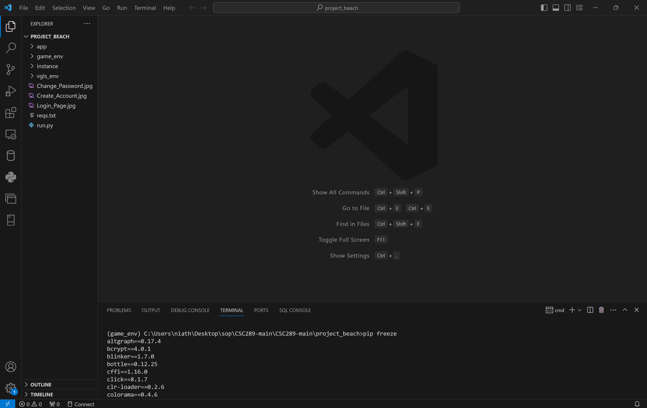

1. There are issues with the current version of the Werkzeug module. You will then need to uninstall the Werkzeug module and install a previous version, Werkzeug 2.3.7, by typing pip uninstall werkzeug. You will type y, then press the Enter key to verify you want to uninstall the module.

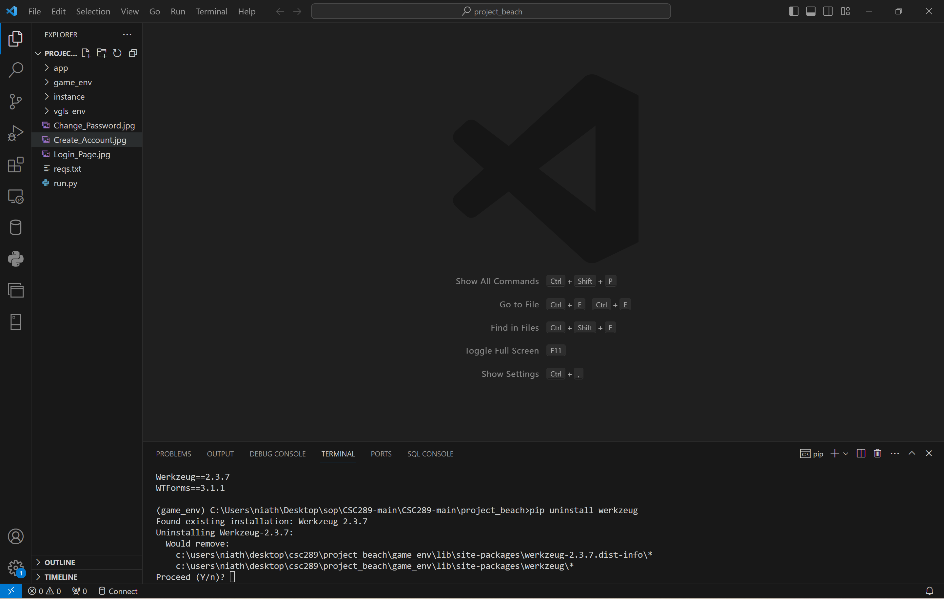

1. You will now need to install werkzeug version 2.3.7 by typing pip install werkzeug==2.3.7. It will then install Werkzeug version 2.3.7.

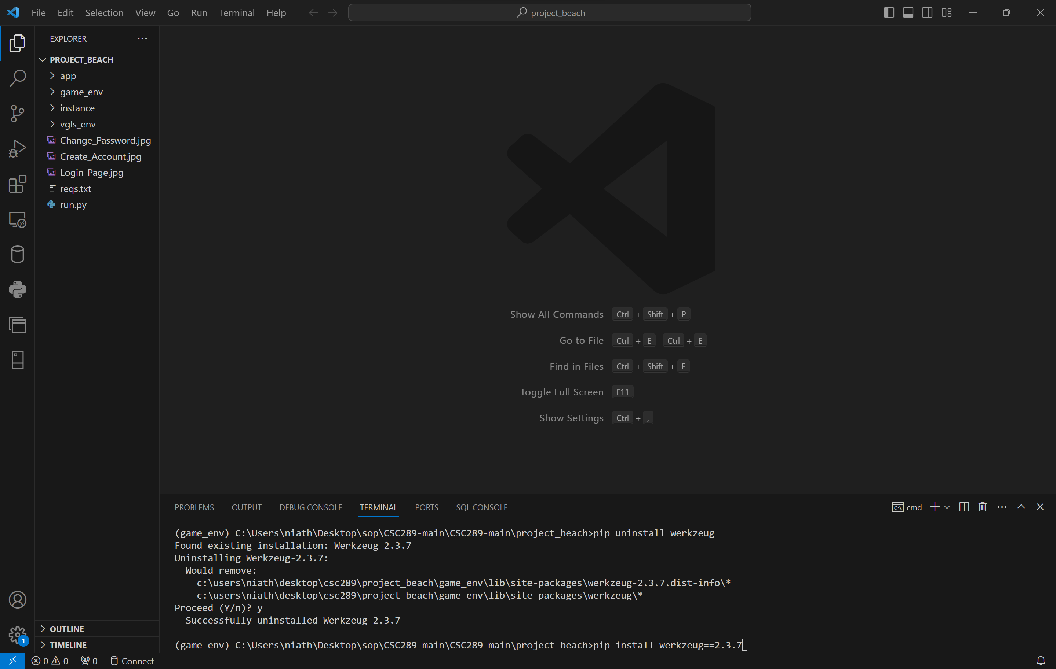

# **Initialize the Website**

1. Type the following command: python run.py to bring up the link you will click on to open a web browser.

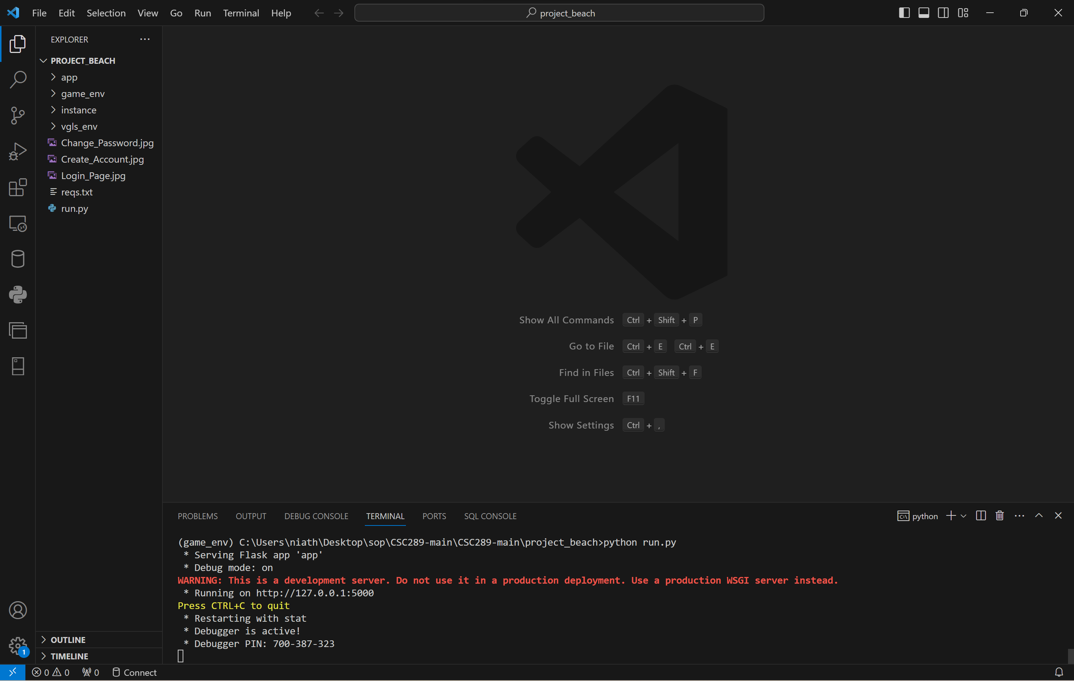

1. Press the Ctrl button and click on the IP address <http://127.0.0.1:5000>. It will then pull up the welcome page of the Video Game Library & Sales Website.

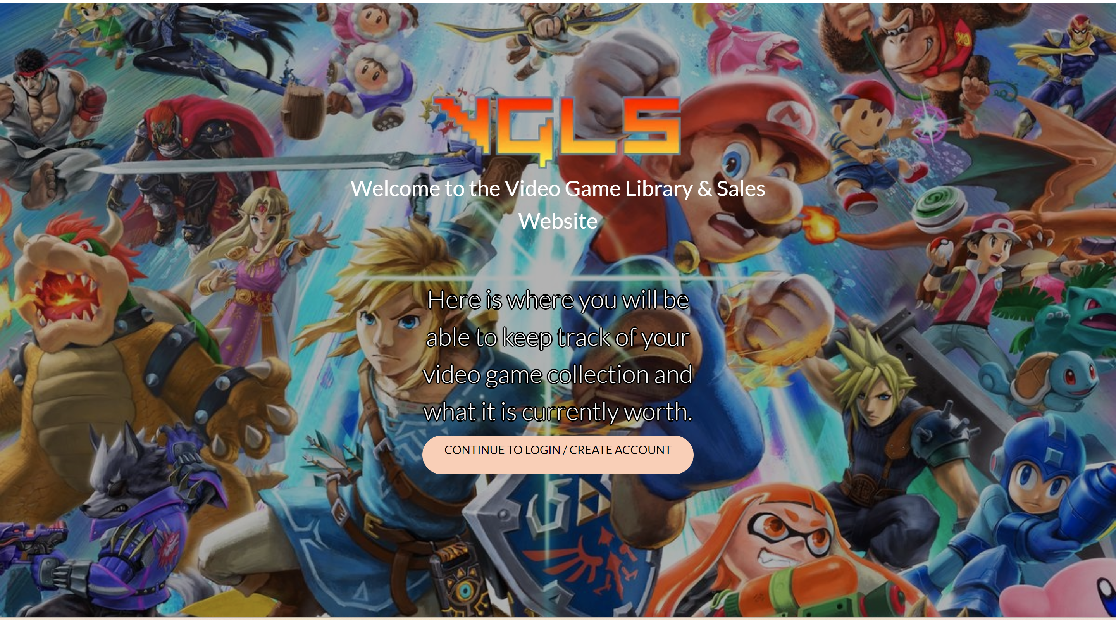

# **Using the Website**

In this section, we will cover how to use the website. The website will be fully searchable for users that do not have an account. If the user wants to build a library of their video games and possibly wants to sell them one day, they can create a video game/console/accessory library and add items to this library.

## **Website Registration**

1. To get to the Registration/Login page, you will click on the link on the welcome link. It will then send you to the sign-in page. To create an account, you will click on the Create Account link.

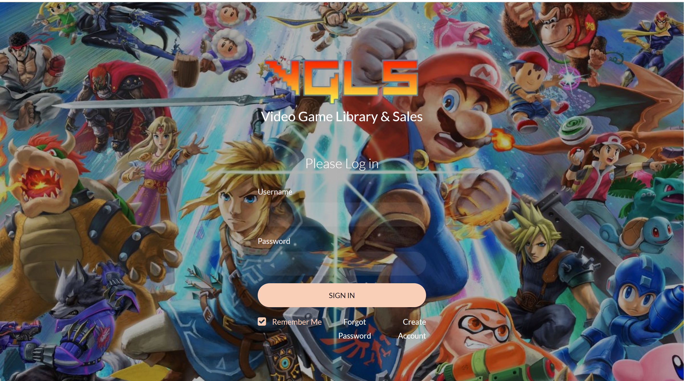

1. You will create a username and password and enter your first and last name. You will then click on Register Account. It will accept your input if the username is not used and redirect you to the login page. You will get an error message to select a new username if the username already exists.

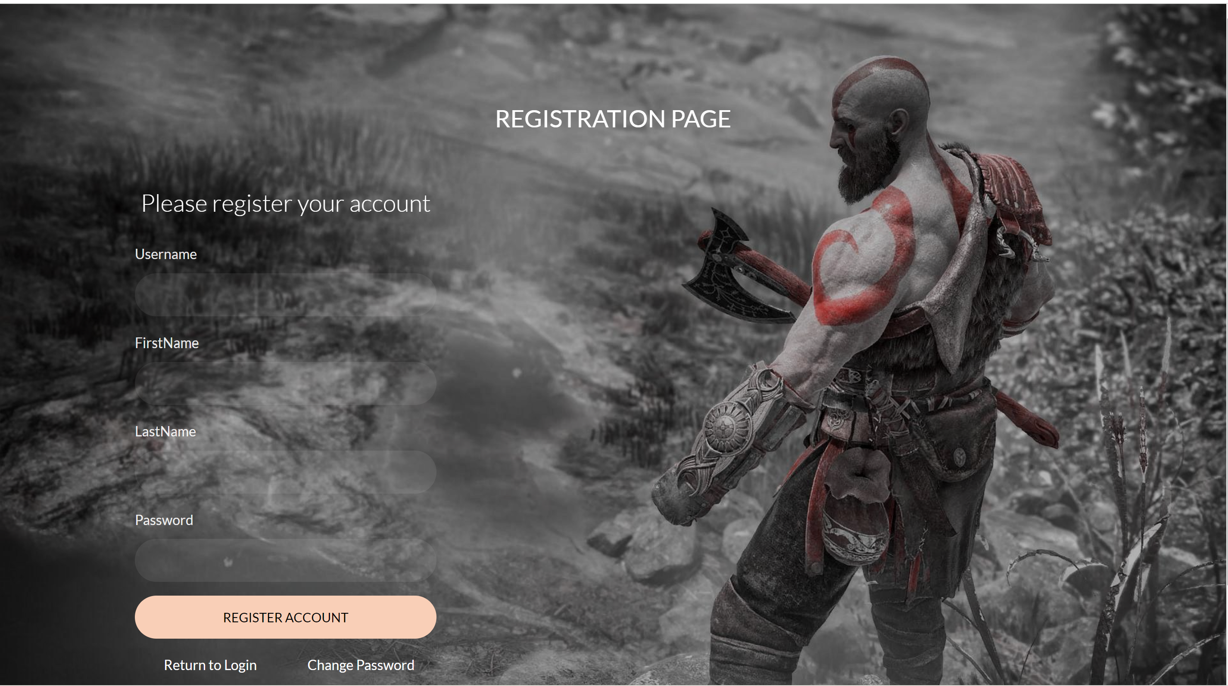

1. If you forgot your password to log in, click on Change Password from the login Screen. You can input your username, type in your new password, and click Change Password. If the username exists, then you can change your password. If the username does not exist, you will get an error message.

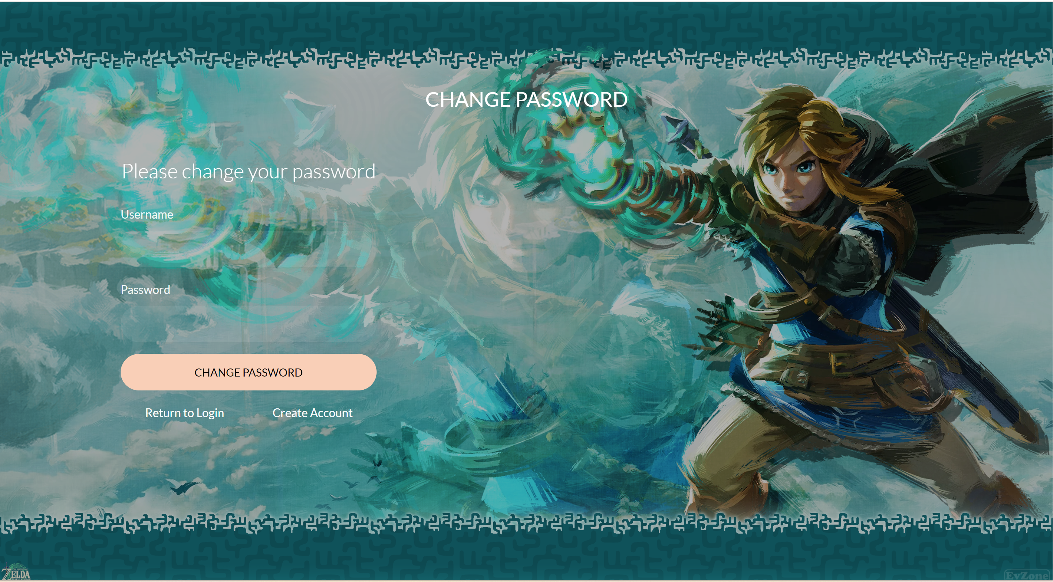

1. To log into the website, you will type your username and password, then click on Sign In.